1. INTRODUCTION
  - Overview
The present day ac power distribution systems are suffering from severe power quality problems such as poor voltage regulation, high reactive power and harmonic current burden, load unbalancing, excessive neutral current etc. To provide transmission-line voltage support, a static compensator (STATCOM) offers the optimal solution\ in terms of price, reliability, and dynamic performance [2], [3]. Generally, multi-pulse-converter-based [4] and multilevel converter- based [5]–[8] solutions are used for high-power applications.
A multi-pulse converter uses more than one voltage source converter (VSC), with common dc link, operating with nearly fundamental switching frequency, and the output of each module is connected in series through the multipulse transformer. By adjusting the triggering pulses of different VSCs, specified total harmonic distortion (THD) of the injected current is achieved with reduced switching losses as compared to that of single-VSC-based solution.
The major drawback of this scheme is the high cost and complex structure of the bulky multipulse transformer. To address some of the aforementioned limitations in multilevel converters, a four-level open-ended-transformer-based multilevel converter, is proposed in [1]. This topology uses a reduced number of components (12 controlled switches with anti parallel diodes) as compared to the diode clamped topology (18 controlled switches with antiparallel diodes plus 18 diodes) [5]. Moreover, in this case, semiconductor switches are arranged as VSC, which enables easier structural layout and reduced driver circuit complexity.
Therefore, standard VSC power modules [include six insulated-gate bipolar transistors (IGBTs) and their driver circuits in one package] can be used instead of discrete components. Moreover, this topology utilizes cascade connection of three-phase VSCs, and hence, the size of the dc-link capacitor is less as compared to that in cascaded H-bridge multilevel converter. The reduced number of dc links makes voltage regulation easier as compared to that in an equivalent cascaded converter. Comparison of diode clamped converter, cascaded converter, and open ended transformer topologies for various parameters is given in [1].
The open-ended transformer topology has similar component layout with twin converter topology, reported in [24]. In the twin converter topology, the dc-link voltages of both VSCs are maintained equal. Therefore, only three-level operation is achieved. However, in the open-ended transformer topology, the dc-link voltage of VSC-2 is regulated to half that of VSC-1. This ensures four-level operation of the circuit [1]. Therefore, low THD is achieved with reduced filter requirements as compared to three-level twin converter topology.
A four-level static compensator integrating two 2-level converters, supplying/absorbing reactive power to/from the grid, is reported in our earlier paper. Reduced component count, simpler layout for switches, and smaller dc-link capacitor values are the attractive features of the proposed topology over the diode clamped and cascaded multilevel converters. This paper suggests further improvements in this topology. Suitable selection of the dc-link voltage values reduces distortion in the current fed to the grid. In addition, circuit topology is modified to avoid the split-capacitor dc links. This reduces the number of independent dc capacitor voltages to be controlled and eliminates the flow of third-harmonic current through the transformer. In order to improve the performance, a phase-shifted carrier-based pulse width modulation technique is used. A mathematical model of the system is derived, based on which a controller for the scheme is designed. The effectiveness of the scheme is verified through detailed simulation study. To confirm the viability of the scheme, experimental studies are carried out on a scaled-down laboratory prototype developed for the purpose.
  - Literature Survey
The power electronic devices, due to their inherent non-linearity draw harmonics and reactive power from the power supply. In three-phase systems, they sometimes also cause unbalance and draw excessive neutral currents lead to low system efficiency and poor power factor.
FACTS were first proposed by the author in 1985. Since then through EPRI and others R&D funding, several FACTS Controllers, also referred to as FACTS Devices, have been demonstrated. IEEE and CIGRE Working Groups have produced guides and documents on various aspects of FACTS technology and applications including planning guide. Numerous Universities throughout the world have undertaken research and published many papers on their ideas of FACTS Controllers, their potential applications and benefits. Many Universities have introduced Power Electronics including HVDC, FACTS and Custom Power in to their Power System curriculum and producing new generation of power system engineers. While the author believes that routine application of FACTS technology as inevitable, application of FACTS technology has lagged behind expectations, largely due to market uncertainties created by regulatory environment, and to some extent consolidation among transmission businesses during long period of downturn in transmission businesses. In general, power electronics provides an opportunity for enhanced value of transmission in terms of loading capability, reliability and availability and flexibility of AC transmission Given the proven commercially available state-of-the-art, FACTS technology can provide stability, voltage control and network loading control. It can also enhance available transmission capacity for given transmission facilities or upgraded and new transmission facilities. Potentially for the future, if economically viable short-time storage becomes available, it can also serve the functions of rapid frequency control and may be even system restarts.
Fang Zheng Peng proposed a power line conditioner using multilevel topology, i.e., cascaded converter topology, comprises several single-phase H-bridge/full-bridge converters, with separate dc links. The following are the two associated problems of this topology is, the size of the dc-link capacitor required is high because the instantaneous power involved with each module varies at twice the fundamental frequency. Regulating voltage across a large number of self-supported dc-link capacitors makes the controller design complex [9].
Diego soto proposed a comparison of high power converter topologies for the implementation of FACTS controller In the twin converter topology, requires multipulse-converter-based solutions are used. The major drawback of this scheme is the high cost and complex structure [4].
B. G. Fernandes proposed a four level open ended transformer based STATCOM it requires 18 controlled switches with anti-parallel diodes, it increases the circuit complexity. In this topology the dc-link voltages of both VSCs are maintained equal. It uses split capacitor arrangement. This requires a complex controller and generates third-harmonic, dc currents [1].
Sandeep Anand proposed DC Voltage controller for Asymmetric twin converter topology based high power STATCOM requires 12 controlled switches with anti-parallel diodes, two dc links without split capacitor arrangement. In the open-ended transformer topology the dc-link voltage of VSC-2is regulated to half that of VSC-1. This ensures four-level operation of the circuit [1].
  - Objective of the Work
The objective of this work is
- To Enhance the voltage Regulation, Harmonic Suppression by a Twin- converter- Topology and Static Compensator (STATCOM).
- To implement the control algorithm by using PI and Fuzzy controllers.
- To compare the results of both controllers based on the Total Harmonic Distortion of source currents.
  - Organization of Thesis
CHAPTER 1: The work carried out, in this project, has been organized in six chapters. The present chapter introduces the overview, literature Survey, objective of thesis.
CHAPTER 2: Various FACTS devices and control techniques are explained in this chapter.
CHAPTER 3: In this chapter the multilevel inverters were explained.
CHAPTER 4: In this chapter DC Voltage controllers for STATCOM with load are explained.
CHAPTER 5: In chapter DC Voltage controller for STATCOM under fault dit conditions .
CHAPTER 6: In this chapter conclusions and future scope are discussed.

2. FACTS DEVICES &PI, FUZZY CONTROLLERS
2.1 Introduction
The Power system is an interconnection of generating units and load centers through high voltage transmission lines. The purpose of interconnection is to pool power plants and load centers in order to minimize the total power generation capacity and fuel cost. Transmission interconnection enables the advantage of diversity of loads, availability of sources and fuel price in order to supply electricity to the loads at minimum cost with a required reliability.
Generally the larger portions of the power systems network are mechanically controlled. The problem with mechanical devices is that control cannot be initiated frequently, because these mechanical devices tend to wear out very quickly compared to static devices. So mechanical switches needs to be supplemented by rapid response power electronic devices. The limitations leads to the development of variety of ingenious techniques to make the system work effectively, but at a price of providing greater operating margins and redundancies. These represent an asset that can be effectively utilized with prudent use of FACTS technology substitute for mechanical switches.
In recent years, greater demands have been placed on the transmission network, and these demands will continue to increase because of the increasing number of non-utility generators and heightened competition among the utilities themselves. Increased demands on transmission, absence of long term planning, and the need to provide open access to generating companies and customers, all together have created tendencies toward less security and reduced quality of supply. The FACTS technology is essential to alleviate some but not all of these difficulties by enabling utilities to get the most service from their transmission facilities and enhance grid reliability.

2.1.1 Opportunities for FACTS
The most interesting for transmission planners is that FACTS technology opens up new opportunities for controlling power and enhancing the usable capacity of present, as well as new and upgraded lines. The possibility that a current through a line can be controlled at a reasonable cost enables a large potential of increasing the capacity of exiting lines with larger conductors, and use of one of the FACTS controllers to enable corresponding power to flow through such lines under normal and contingency conditions.
These opportunities arise through the ability of FACTS controllers to control the inter related parameters that govern the operation of transmission system including series impedance, shunt impedance, current, voltage and the damping of oscillations at various frequencies below rated frequency. These constraints cannot be overcome, while maintain the required system reliability, by mechanical means without lowering the usable transmission capacity. By providing added flexibility, FACTS controllers can enable a line to carry power closer to its thermal rating. The FACTS technology is not a single high-power controller, but rather a collection of controllers, which can be applied individually or in coordination with others to control one or more of the inter related system parameters.
FACTS technology also lends itself to extending usable transmission limits in a step by step manner with incremental investment as and when required. The transmission lines will involve a combination of mechanical and FACTS controllers to achieve the objective in an appropriate, signed investment scenario.
Flexibility of electric power transmission The ability to accommodate changes in the electric transmission system or operating conditions while maintaining sufficient steady state and transient margins.
Flexible AC Transmission System (FACTS) Alternating current transmission systems incorporating power electronic-based and other static controllers to enhance controllability and increase power transfer capability.
FACTS Controller A power electronic based system and other static equipment that provide control of one or more AC transmission system parameters.

2.2 Basic types of FACTS controllers
In general FACTS controllers can be divided into four categories. They are
- Series controllers
- Shunt controllers
- Combined series-series controllers
- Combined series-shunt controllers
2.2.1 Series controllers
The Series Controller could be variable impedance, such as capacitor, reactor, etc., or power electronics based variable source of main frequency, sub synchronous and harmonic frequencies (or a combination) to serve the desired need. In principle, all series controllers inject voltage in series with the line. Even variable impedance multiplied by the current flow through it, represents an injected series voltage in the line. As long as the voltage is in phase quadrature with the line current, the series controller only supplies or consumes variable reactive power. Any other phase relationship will involve handling of real power as well. The general block diagram for series controllers is shown in Fig. 2.1.
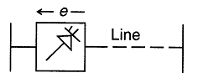
Fig: 2.1 Series Controller
Examples for series controllers
- Static Series Synchronous Compensator (SSSC)
- Thyristor Controlled Series Capacitor (TCSC)
They can be effectively used to control the current power flow in the system and to damp system’s oscillations.
2.2.1.1 Static series synchronous compensator (SSSC)
A static synchronous generator operated without an external energy source as a series compensator whose output voltage is in quadrature with and controllable independently, of the line current for the purpose of controlling the transmitted electric power. The SSSC may include transiently rated energy storage by additional temporary real power compensation, to increase or decrease momentarily the overall real voltage drop across the line.
2.2.1.2 Thyristor controlled series capacitor (TCSC)
A capacitive reactive compensator which consists of a series capacitor bank by a thyristor controlled reactor in order to provide a smoothly variable series capacitive reactance.
2.2.2 Shunt controllers
As in the case of series controllers, the shunt controllers may be variable impedance, variable source, or a combination of these. In principle, all shunt controllers inject current in to the system at the point of connection. Even, variable shunt impedance connected to the line voltage causes a variable current flow and hence represents injection of current into the line. As long as the injected current is in phase quadrature with the line voltage, the shunt controller only supplies or consumes variable reactive power. Any other phase relationship will involve handling of real power as well. The general block diagram for shunt controller is shown in Fig. 2.2.
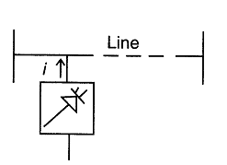
Fig: 2.2 Shunt controller
Examples for shunt controllers
- Static Synchronous Compensator (STATCOM)
- Static Synchronous Generator (SSG)
- Static Var Compensator (SVC)
They can be used as a good way to control the voltage in and around the point of connection by injecting the active or reactive current in to the system.
2.2.2.1 Static synchronous compensator (STATCOM)
This is a Static Synchronous Generator operated as a shunt connected Static Var Compensator whose capacitive or inductive output current can be controlled independent of the ac system voltage.
2.2.2.2 Static synchronous generator (SSG)
A Static Self Commutated switching power converter supplied from an appropriate electric energy source and operated to produce a set of adjustable multiphase output voltages, which may be coupled to an ac power system for the purpose of exchange independently controllable real and reactive power.
2.2.2.3 Static var compensator (SVC)
It is a shunt connected static var generator or absorber whose output is adjusted to exchange capacitive or inductive current so as to maintain control over the specific parameters of the electrical power system.
2.2.3 Combined series-series controllers
This could be combination of separate series controllers, which are controlled in a coordinated manner, in a multilane transmission system. Or it could be a unified controller, which series controllers provide independent series reactive compensation for each line but also transfer real power among the lines via a power link.
The real power transfer capability of the unified series-series controller, referred to as Interline Power Flow Controller, makes it possible to balance both the real and reactive power flow in the lines and thereby maximize the utilization of the transmission system. Note that the term “unified” here means that the dc terminals of all controller converters are all connected together for real power transfer. The block diagram of combined series-series controller is shown in Fig. 2.3.

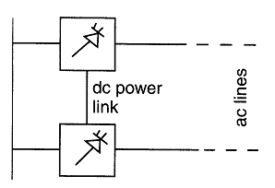
Fig: 2.3 Combined Series-Series Controller
Interline Power Flow Controllers (IPFC) is an example for combined series-series controllers which helps in balancing both the real and reactive power flows on the lines.
2.2.4 Combined series-shunt controllers
This could be a combination of separate shunt and series controllers, which are controlled in a coordinated manner, or a Unified Power Flow Controllers with series and shunt elements. In principle, combined shunt and series controllers inject current into the system with the shunt part of the controller and voltage in series in the line with the series part of the controller. However, when the shunt and series controllers are unified, there can be a real power exchange between the series and shunt controllers via the power link and angle or alternatively both the real power and reactive power flow in the line. The general block diagram for combined series-shunt controller is shown in Fig. 2.4.
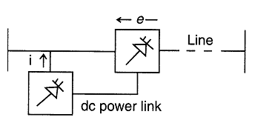
Fig: 2.4 Combined Series-Shunt Controller
Example for Combined Series-Shunt Controller

2.2.4.1 Unified power flow controller (UPFC)
Unified Power Flow Controller (UPFC) makes use of the advantages of both series and shunt controllers and hence facilitates effective and independent power or current flow and line voltage control.
A combination of static synchronous compensator (STATCOM) and a static series compensator (SSSC) which are coupled via a common dc link to allow bidirectional flow of real power between the series output terminals of SSSC and the shunt output terminals of STATCOM and are controlled to provide concurrent real and reactive series line compensation without an external electric energy source. The UPFC by means of angularly unconstrained series voltage injection is able to control concurrently or selectively the transmission line voltage, impedance and angle or alternatively both the real power and reactive power flow in the line.
2.3 Benefits of utilizing FACTS devices
- Control of power flow control, as desired and within limits, is possible.
- Reduction of voltage drop in power lines is possible. Regulation can be improved.
- Reduction of reactive burden on line allows more flow of active power in lines.
- Loadability of lines is increased.
- Voltage stability and voltage security are enhanced.
- Generation cost reduces.
- Transient stability is increased.
- Passive compensation requirement reduces.
2.4 Structure of STATCOM
STATCOM (Static Compensator), which is schematically depicted in Figure 2.5, consists of a two-level Voltage Source Converter (VSC), a dc energy storage device, a coupling transformer connected in shunt to the distribution network through a coupling transformer. The VSC converts the dc voltage across the storage device into a set of three-phase ac output voltages. These voltages are in phase and coupled with the ac system through the reactance of the coupling transformer. Suitable adjustment of the phase and magnitude of the STATCOM output voltages allows effective control of active and reactive power exchanges between the STATCOM and the ac system. Such configuration allows the device to absorb or generate controllable active and reactive power. But, there are several factors that must be considered when designing the STATCOM and associated control circuits. In relation to the power circuit the following issues are of major importance.
- DC link capacitor size
- Coupling transformer reactance and transformation ratio
- Output filters equipment
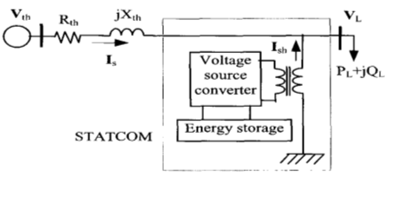
Fig.2.5. Schematic diagram of a STATCOM
But there are several factors that must be considered when designing the STATCOM and associated control circuits. In relation to the power circuit the following issues are of major importance:
- DC link capacitor size
- Coupling transformer reactance and transformation ratio
- Output filters equipment
The VSC connected in shunt with the ac system provides a multifunctional topology which can be used for up to three quite distinct purposes:
- 1. Voltage regulation and compensation of reactive power
- 2. Correction of power factor
- 3. Elimination of current harmonics.
2.4.1 Principle of Operation
STATCOM is to suppress voltage variation and control reactive power in phase with system voltage. It can compensate for inductive and capacitive currents linearly and continuously. Figure 2.6 shows the vector diagram at the fundamental frequency for capacitive and inductive modes and for the transition states from capacitive to inductive and vice versa. The terminal voltage (V_{bus}) is equal to the sum of the inverter voltage (V_{VSC}) and the voltage across the coupling transformer reactance V_{L} in both capacitive and inductive modes. I mean that if output voltage of STATCOM (V_{VSC}) is in phase with bus terminal voltage (V_{bus}) and V_{VSC} is greater than V_{bus}, STATCOM provides reactive power to system. And if V_{VSC} is smaller than V_{bus}, STATCOM absorbs reactive power from power system. V_{bus} and V_{VSC} have the same phase, but actually they have a little phase difference to compensate the loss of transformer winding and inverter switching, so absorbs some real power from system.
Figure 2.6 is STATCOM vector diagrams, which show inverter output voltage V_{I}, system voltage V_{T}, reactive voltage V_{L} and line current I in correlation with magnitude and phase δ. Figure 2.6a and b explain how V_{I} and V_{T} produce capacitive or inductive power by controlling the magnitude of inverter output voltage V_{I} in phase with each other. Figure 2.6c and d show STATCOM produces or absorbs real power with VI and V_{T} having phase±δ. The transition from inductive to capacitive mode occurs by changing angle δ from zero to a negative value. The active power is transferred from the AC terminal to the DC capacitor and causes the DC link voltage to rise. The active and reactive power may be expressed by the following equations:

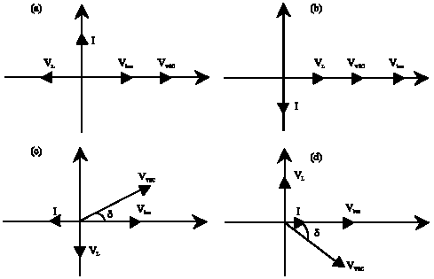
Figure 2.6: Vector diagram of STATCOM (a) Capacitive mode, (b) Inductive mode, (c) Active power release and (d) Active power absorption
2.4.2 Modeling of STATCOM
It is assumed that the source is a balance, sinusoidal three-phase voltage supply with the frequency ω. Since reactive power compensation is desired, it is convenient for this analysis to take the angle of the input the reference angle. However the system is designed based on following assumptions.
- The three AC mains voltages are balanced
- The three - phase load is balanced and linear
- The inverter switches are ideal
- DC link output is ripple free
- The filter components are reactive and linear
A STATCOM, consists of a two-level Voltage Source Converter (VSC), a DC energy storage device, a coupling transformer connected in shunt to the distribution network through a coupling transformer. The VSC converts the DC voltage across the storage device into a set of three-phase AC output voltages. These voltages are in phase and coupled with the AC system through the reactance of the coupling transformer. Suitable adjustment of the phase and magnitude of the STATCOM output voltages allows effective control of active and reactive power exchanges between the STATCOM and the AC system. Such configuration allows the device to absorb or generate controllable active and reactive power.
A single-phase equivalent circuit of STATCOM is shown in Fig. 2.7 Where, R_{c} is included to represent small losses in the switching devices of VSC. R_{s} and L represent the equivalent circuit of the tie-transformer between system voltages U_{s} and the output voltage U_{I} of STATCOM.
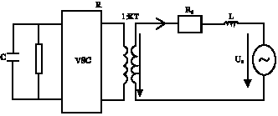
Figure.2.7: Single-phase equivalent circuit of STATCOM
The U_{sa}, U_{sb}, U_{sc} are defined as instantaneous values of system phase voltage and can be given by:
where, U_{s} is rms value of system phase voltage. The output voltages of STATCOM, u_{ja}, u_{ib} and u_{ic} can be given by:
where, KT is turn’s ratio of the tie-transformer, m is the amplitude modulation ratio of VSC output voltage; its value depends on the type of VSC. U_{DC} is the DC-link capacitor`s voltage of VSC and is the phase angle difference between voltage u_{s} and current Is.
2.4.3. Voltage sag correction by a STATCOM
The schematic diagram of a STATCOM is shown in following fig 1.4. In this diagram, the shunt injected current Ish corrects the voltage sag by adjusting the voltage drop across the system impedance &h. The value of Ish can be controlled by adjusting the output voltage of the converter. The shunt injected current Ish can be written as
2.5 Proportional- Integral (PI) Control
The combination of proportional and integral terms is important to increase the speed of the response and also to eliminate the steady state error. The PID controller block is reduced to P and I blocks only as shown in Figure 2.9.
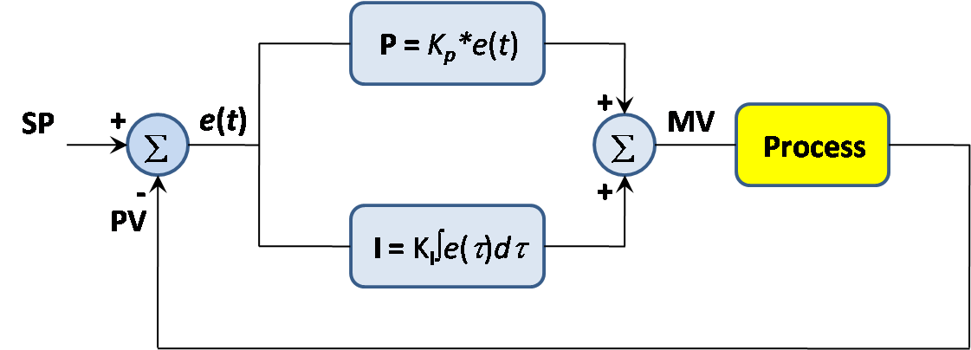
Figure 2.8: Proportional Integral (PI) Controller block diagram
The proportional and integral terms is given by:
are the tuning knobs, are adjusted to obtain the desired output.
Disadvantages of PI Control
- Integral action tends to increase the oscillatory or rolling behavior of the measured variable
- There are two tuning parameters (Kc and ) and they interact with each other
- This interaction can make it challenging to arrive at “best” tuning values

3. MULTILEVEL VOLTAGE-SOURCE CONVERTERS FOR STATCOM APPLICATIONS
3. 1 Multilevel inverter structures
A voltage level of three is considered to be the smallest number in multilevel converter topologies. Due to the bi-directional switches, the multilevel VSC can work in both rectifier and inverter modes. This is why most of the time it is referred to as a converter instead of an inverter in this dissertation. A multilevel converter can switch either its input or output nodes (or both) between multiple (more than two) levels of voltage or current. As the number of levels reaches infinity, the output THD approaches zero. The number of the achievable voltage levels, however, is limited by voltage-imbalance problems, voltage clamping requirements, circuit layout and packaging constraints complexity of the controller, and, of course, capital and maintenance costs.
Three different major multilevel converter structures have been applied in industrial applications:
- Diode clamped multilevel inverters.
- Flying capacitors, and
- Cascaded H-Bridge multilevel inverters.
The multilevel inverter structures are the main focus of discussion in this chapter: however, the illustrated structures can be implemented for rectifying operation as well. Although each type of multilevel converters share the advantages of multilevel voltage source inverters, they may be suitable for specific application due to their structures and drawbacks. Operation and structure of some important type of multilevel converters are discussed in the following sections.
In a multilevel VSI, the dc-link voltage Vdc is obtained from any equipment which can yield stable dc source. Series connected capacitors constitute energy tank for the inverter providing some nodes to which multilevel inverter can be connected. Primarily, the series connected capacitors will be assumed to be any voltage sources of the same value. Each capacitor voltage Vc is given by Vc=Vdc/ (n-1), where n denotes the number of level.
Fig. 3.1 shows a schematic diagram of one phase leg of inverters with different number of levels, for which the action of the power semiconductors is represented by an ideal switch with several positions. A two-level inverter generates an output voltage with two values (levels) with respect to the negative terminal of the capacitor, while the three-level inverter generates three voltages, and so on.
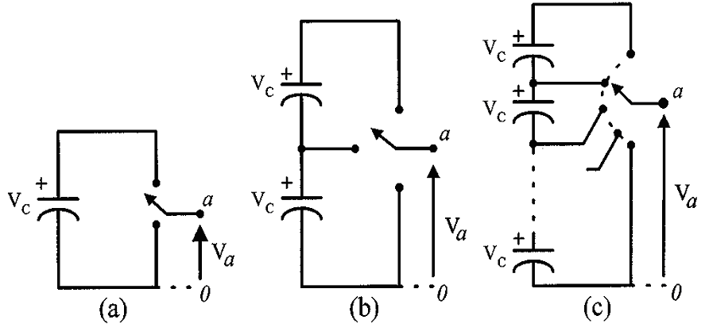
Fig: 3.1 One phase leg of an inverter with (a) two levels, (b) three levels, and (c) n levels
3.1.1 Diode-clamped multilevel inverter
The most commonly used multilevel topology is the diode clamped inverter, in which the diode is used as the clamping device to clamp the dc bus voltage so as to achieve steps in the output voltage. The neutral point converter proposed by Nabae, Takahashi, and Akagi in 1981 was essentially a three-level diode-clamped inverter. A three-level diode clamped inverter consists of two pairs of switches and two diodes. Each switch pairs works in complimentary mode and the diodes used to provide access to mid-point voltage. In a three-level inverter each of the three phases of the inverter shares a common dc bus, which has been subdivided by two capacitors into three levels. The DC bus voltage is split into three voltage levels by using two series connections of DC capacitors, C1 and C2. The voltage stress across each switching device is limited to Vdc through the clamping diodes Dc1 and Dc2. It is assumed that the total dc link voltage is Vdc and mid point is regulated at half of the dc link voltage, the voltage across each capacitor is Vdc/2 (Vc1=Vc2=Vdc/2). In a three level diode clamped inverter, there are three different possible switching states which apply the stair case voltage on output voltage relating to DC link capacitor voltage rate. For a three-level inverter, a set of two switches is on at any given time and in a five-level inverter, a set of four switches is on at any given time and so on. Fig. 3.2. shows the circuit for a diode clamped inverter for a three-level and a five-level inverter. Switching states of the three level inverter are summarized in table 3.1.
Table-3.1. Switching states in one leg of the three-level diode clamped inverter
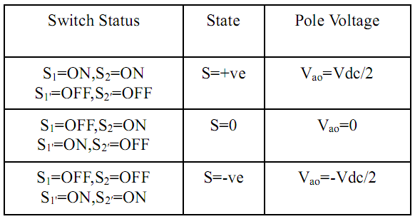
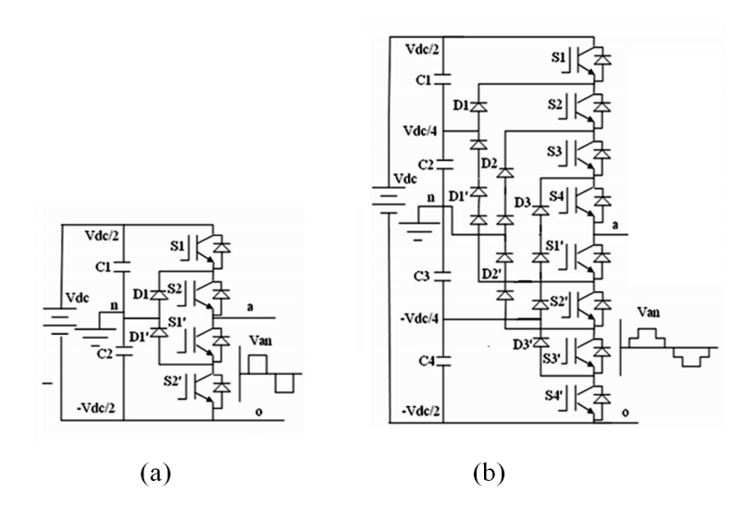
Fig: 3.2 Topology of the diode-clamped inverter (a) three-level inverter, (b) five -level inverter.
Fig 3.3 shows the phase voltage and line voltage of the three-level inverter in the balanced condition. The line voltage Vab consists of a phase-leg a voltage and a phase-leg b voltage. The resulting line voltage is a 5-level staircase waveform for three-level inverter and 9-level staircase waveform for a five-level inverter. This means that an N-level diode-clamped inverter has an N-level output phase voltage and a (2N-1)-level output line voltage. In general the voltage across each capacitor for an N level diode clamped inverter at steady state is Vdc/ (N-1). Although each active switching device is required to block only a voltage level of Vdc, the clamping diodes require different ratings for reverse voltage blocking.
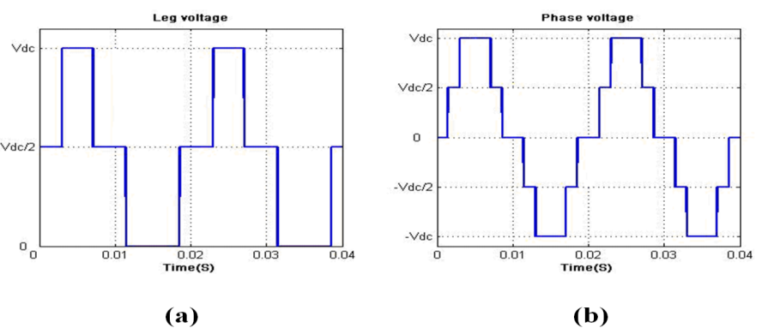
Figure: 3.3. Output voltage in three-level diode- clamped inverter (a) leg voltage (b) output phase voltage
In general for an N level diode clamped inverter, for each leg 2(N-1) switching devices, (N-1) * (N-2) clamping diodes and (N-1) dc link capacitors are required. By increasing the number of voltage levels the quality of the output voltage is improved and the voltage waveform becomes closer to sinusoidal waveform. However, capacitor voltage balancing will be the critical issue in high level inverters. When N is sufficiently high, the number of diodes and the number of switching devices will increase and make the system impracticable to implement. If the inverter runs under pulse width modulation (PWM), the diode reverse recovery of these clamping diodes becomes the major design challenge. Though the structure is more complicated than the two-level inverter, the operation is straightforward.
3.1.2 Operation of DCMLI
Fig 3.6(a) shows a three-level diode-clamped converter in which the dc bus consists of two capacitors, C1, C2. For dc-bus voltage Vdc, the voltage across each capacitor is Vdc/2 and each device voltage stress will be limited to one capacitor voltage level Vdc/2 through clamping diodes. To explain how the staircase voltage is synthesized, the neutral point n is considered as the output phase voltage reference point. There are three switch combinations to synthesize three-level voltages across a and n.
1) Voltage level Van= Vdc/2, turn on the switches S1andS2.
2) Voltage level Van= 0, turn on the switches S2 and S1′.
3) Voltage level Van= - Vdc/2 turn on the switches S1′, S2′.
Fig 3.6(b) shows a five-level diode-clamped converter in which the dc bus consists of four capacitors, C1, C2, C3, and C4. For dc-bus voltage Vdc, the voltage across each capacitor is Vdc/4 and each device voltage stress will be limited to one capacitor voltage level Vdc/4 through clamping diodes.
Switching states of the five level inverter are summarized in table 3.2.
Table-3.2. Switching states in one leg of the five-level diode clamped inverter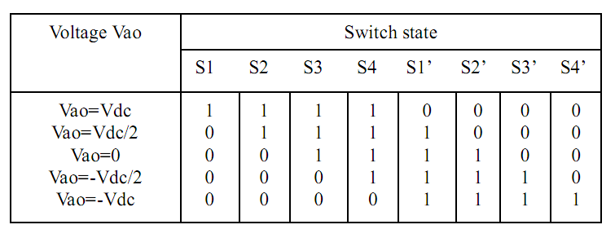
To explain how the staircase voltage is synthesized, the neutral point n is considered as the output phase voltage reference point. There are five switch combinations to synthesize five level voltages across a and n.
- Voltage level Van= Vdc, turn on all upper switches S1, S2, S3 and S4.
2) Voltage level Van= Vdc/2, turn on the switches S2, S3, S4 and S1′.
3) Voltage level Van= 0, turn on the switches S3, S4, S1′ and S2′.
4) Voltage level Van= - Vdc/2 turn on the switches S4, S1′, S2′, S3′.
5) Voltage level Van= - Vdc, turn on all lower switches S1′, S2′, S3′ and S4′.
Four complementary switch pairs exist in each phase. The complementary switch pair is defined such that turning on one of the switches will exclude the other from being turned on. In this example, the four complementary pairs are (S1 –S1′), (S2- S2′), (S3 – S3′), and (S4 - S4′).
Although each active switching device is only required to block a voltage level of Vdc/ (m-1), the clamping diodes must have different voltage ratings for reverse voltage blocking. Using D1′ of Fig 3.6(b) as an example, when lower devices S₂′- S4′, are turned on, D1′needs to block three capacitor voltages, or 3Vdc/4, and D1 needs to block Vdc/4. Similarly, D2 and D2′ need to block 2Vdc/4, and D3 needs to block 3Vdc/4. Assuming that each blocking diode voltage rating is the same as the active device voltage rating, the number of diodes required for each phase will be (m-1)*(m-2). This number represents a quadratic increase in m.
There are some complementary switches and in a practical implementation, some dead time is inserted between the gating signals and their complements meaning that both switches in a complementary pair may be switched off for a small amount of time during a transition. However, for the discussion herein, the dead time will be ignored.
3.1.3 Features of diode clamped MLI
1) High-Voltage Rating Required for Blocking Diodes:
Although each active switching device is only required to block a voltage level of Vdc/(m - l), the clamping diodes need to have different voltage ratings for reverse voltage blocking. Using D1′ of Fig 3.6(b) (5-level diode clamped inverter) as an example, when all lower devices, S1′-S4′ are turned on, D1′ needs to block three capacitor voltages, or 3Vdc/4. Similarly, D2 and D2′ need to block 2Vdc/4, and D3 needs to block 3Vdc/4. Assuming that each blocking diode voltage rating is the same as the active device voltage rating, the number of diodes required for each phase will be (m-1) x (m- 2). This number represents a quadratic increase in m. When m is sufficiently high, the number of diodes required will make the system impractical to implement.
2) Unequal Device Rating:
In Fig 3.6 it can be seen that switch S1 conducts only during Vao = Vdc, while switch S4 conducts over the entire cycle except during Vao = 0. Such an unequal conduction duty requires different current ratings for switching devices. When the inverter design is to use the average duty for all devices, the outer switches may be oversized, and the inner switches may be undersized. If the design is to suit the worst case, then each phase will have 2 x (m - 2) outer devices oversized. In comparison with the traditional transformer coupling multipulse converters using six-step operation for each converter, such unequal conduction duty is indeed an advantageous feature because the six-step operation needs maximum duty in each device and circulating currents between converters through transformers.
3) Capacitor Voltage Unbalance:
In most applications, a power converter needs to transfer real power from ac to dc (rectifier operation) or dc to ac (inverter operation). When operating at unity power factor, the charging time for rectifier operation (or discharging time for inverter operation) for each capacitor is different. Such a capacitor charging profile repeats every half cycle, and the result is unbalanced capacitor voltages between different levels. The voltage unbalance problem in a multilevel converter can be solved by several approaches, such as replacing capacitors by a controlled constant dc voltage source such as pulse-width modulation (PWM) voltage regulators or batteries. The use of a controlled dc voltage will result in system complexity and cost penalties. With the high power nature of utility power systems, the converter switching frequency must be kept to a minimum to avoid switching losses and electromagnetic interference (EMI) problems. When operating at zero power factor, however, the capacitor voltages can be balanced by equal charge and discharge in one-half cycle. This indicates that the converter can transfer pure reactive power without the voltage unbalance problem.

3.1.4 Advantages and Disadvantages of DCMLI
Advantages:
1. All of the phases share a common dc bus, which minimizes the capacitance requirements of the converter. For this reason, a back-to-back topology is not only possible but also practical for uses such as a high-voltage back-to-back inter-connection or an adjustable speed drive.
2. The capacitors can be pre-charged as a group.
3. Efficiency is high for fundamental frequency switching.
4. When the number of levels is high enough, harmonic content will be low enough to avoid the need for filters.
Disadvantages:
1. Real power flow is difficult for a single inverter because the intermediate dc levels will tend to overcharge or discharge without precise monitoring and control.
2. The number of clamping diodes required is quadratic
ally related to the number of levels [1], which can be cumbersome for units with a high number of levels.
Conclusion
The diode-clamped inverter provides multiple voltage levels through connection of the phases to a series of capacitors. The concept can be extended to any number of levels by increasing the number of capacitors. Early descriptions of this topology were limited to three-levels where two capacitors are connected across the dc bus resulting in one additional level. The additional level was the neutral point of the dc bus, so the terminology neutral point clamped (NPC) inverter was introduced. However, with an even number of voltage levels, the neutral point is not accessible, and the term multiple point clamped (MPC) is sometimes applied. Due to capacitor voltage balancing issues, the diode-clamped inverter implementation has been limited to three level. Because of industrial developments over the past several years, the three level inverter is now used extensively in industrial application.

3.2 Flying capacitor structure
The capacitor clamped inverter alternatively known as flying capacitor was proposed by Meynard and Foch in 1992. The structure of this inverter is similar to that of the diode-clamped inverter except that instead of using clamping diodes, the inverter uses capacitors in their place. The flying capacitor involves series connection of capacitor clamped switching cells. This topology has a ladder structure of dc side capacitors, where the voltage on each capacitor differs from that of the next capacitor. The voltage increment between two adjacent capacitor legs gives the size of the voltage steps in the output waveform. Fig 3.4 shows the three-level and five-level capacitor clamped inverters respectively.
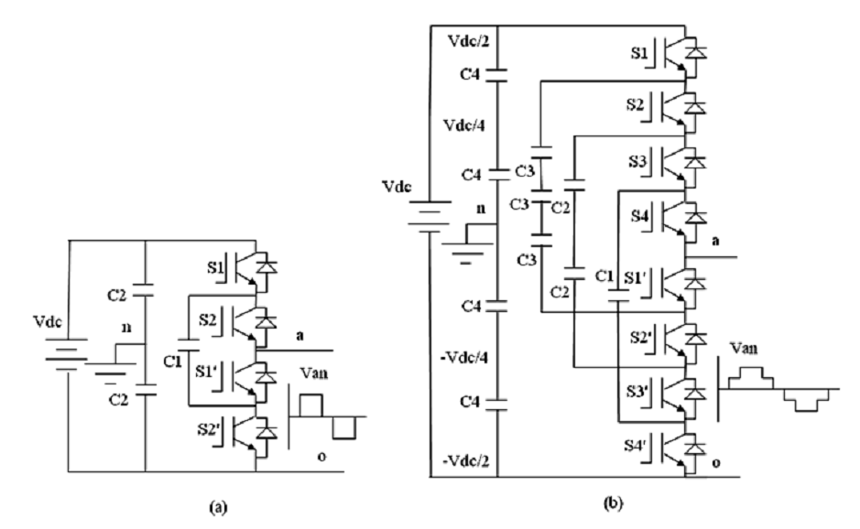
Fig: 3.4 Capacitor-clamped multilevel inverter circuit topologies, (a) 3-level inverter (b) 5- level inverter
3.2.1 Operation of FCMLI
In the operation of flying capacitor multi-level inverter, each phase node (a, b, or c) can be connected to any node in the capacitor bank (V3, V2, V1). Connection of the a-phase to positive node V3 occurs when S1 and S2 are turned on and to the neutral point voltage when S2 and S1′ are turned on. The negative node V1 is connected when S1′ and S2′are turned on. The clamped capacitor C1 is charged when S1 and S1′ are turned on and is discharged when S2 and S2′ are turned on. The charge of the capacitor can be balanced by proper selection of the zero states. In comparison to the three-level diode-clamped inverter, an extra switching state is possible. In particular, there are two transistor states, which make up the level V3. Considering the direction of the a-phase flying capacitor current Ia for the redundant states, a decision can be made to charge or discharge the capacitor and therefore, the capacitor voltage can be regulated to its desired value by switching within the phase. As with the three-level flying capacitor inverter, the highest and lowest switching states do not change the charge of the capacitors. The two intermediate voltage levels contain enough redundant states so that both capacitors can be regulated to their ideal voltages.
Similar to the diode clamped inverter, the capacitor clamping requires a large number of bulk capacitors to clamp the voltage. Provided that the voltage rating of each capacitor used is the same as that of the main power switch, an N level converter will require a total of (N-1) * (N-2) / 2 clamping capacitors per phase in addition to the (N-1) main dc bus capacitors.
Unlike the diode-clamped inverter, the flying-capacitor inverter does not require all of the switches that are on (conducting) in a consecutive series. Moreover, the flying-capacitor inverter has phase redundancies, whereas the diode-clamped inverter has only line-line redundancies. These redundancies allow a choice of charging/discharging specific capacitors and can be incorporated in the control system for balancing the voltages across the various levels.
The voltage synthesis in a five-level capacitor-clamped converter has more flexibility than a diode-clamped converter. Using Fig 3.4(b) as the example, the voltage of the five-level phase-leg’ a’ output with respect to the neutral point n ( i.e. Van ), can be synthesized by the following switch combinations.
1) Voltage level V_{an}= V_{dc}/2, turn on all upper switches S₁ - S₄.
2) Voltage level V_{an}= V_{dc}/4, there are three combinations.
a) Turn on switches S₁, S₂, S₃ and S₁′.(V_{an}= V_{dc}/2 of upper C₄’s - V_{dc}/4 of C1’s).
b) Turn on switches S₂, S₃, S₄ and S₄′.(Van= 3Vdc/4 of upper C₃’s - V_{dc}/2 of C₄’s).
c) Turn on switches S1, S3, S4 and S3′. (V_{an}= V_{dc}/2 of upper C₄’s - 3V_{dc}/4 or C₃’s + V_{dc/2} of upper C₂).
3) Voltage level V_{an}= 0, turn on upper switches S₃, S₄, and lower switch S₁′, S₂′.
4) Voltage level V_{an}= -V_{dc}/4, turn on upper switch S1 and lower switches S₁′, S₂′and S3′.
5) Voltage level V_{an}= -V_{dc}/2, turn on all lower switches S₁′, S₂′, S₃′ and S₄′.
3.2.2 Features of FCMLI
The major problem in this inverter is the requirement of a large number of storage capacitors. Provided that the voltage rating of each capacitor used is the same as that of the main power switch, an m-level converter will require a total of (m-1)x (m -2)/2 auxiliary capacitors per phase leg in addition to (m - 1) main dc bus capacitors. With the assumption that all capacitors have the same voltage rating, an m-level diode-clamp inverter only requires (m - 1) capacitors.
In order to balance the capacitor charge and discharge, one may employ two or more switch combinations for middle voltage levels (i.e., 3Vdc/4. Vdc/2, and Vdc/4) in one or several fundamental cycles. Thus, by proper selection of switch combinations, the flying-capacitor multilevel converter may be used in real power conversions. However, when it involves real power conversions, the selection of a switch combination becomes very complicated, and the switching frequency needs to be higher than the fundamental frequency. In summary, advantages and disadvantages of a flying capacitor multilevel voltage source converter are as follows.
3.2.3 Advantages and Disadvantages of FCMLI
Advantages:
Compared to the diode-clamped inverter, this topology has several unique and attractive features as described below:
1. Added clamping diodes are not needed.
2. It has switching redundancy within the phase, which can be used to balance the flying capacitors so that only one dc source is needed.
3. The required number of voltage levels can be achieved without the use of the transformer. This assists in reducing the cost of the converter and again reduces power loss.
4. Unlike the diode clamped structure where the series string of capacitors share the Same voltage, in the capacitor-clamped voltage source converter the capacitors within a phase leg are charged to different voltage levels.
5. Real and reactive power flow can be controlled.
6. The large number of capacitors enables the inverter to ride through short duration outages and deep voltage sags.
Disadvantages:
1. Converter initialization i.e., before the converter can be modulated by any modulation scheme the capacitors must be set up with the required voltage level as the initial charge. This complicates the modulation process and becomes a hindrance to the operation of the converter.
2. Control is complicated to track the voltage levels for all of the capacitors.
3. Pre-charging all of the capacitors to the same voltage level and startup are complex.
4. Switching utilization and efficiency are poor for real power transmission.
5. Since the capacitors have large fractions of the dc bus voltage across them, rating of the capacitors are a design challenge.
6. The large numbers of capacitor are both more expensive and bulky than clamping diodes in multilevel diode-clamped converters.
7. Packaging is also more difficult in inverters with a high number of levels.
3.3 Cascaded H-Bridge multilevel inverter
The cascaded H-bridge multilevel Inverter uses separate dc sources (SDCSs). The multilevel inverter using cascaded-inverter with SDCSs synthesizes a desired voltage from several independent sources of dc voltages, which may be obtained from either batteries, fuel cells, or solar cells. This configuration recently becomes very popular in ac power supply and adjustable speed drive applications. This new inverter can avoid extra clamping diodes or voltage balancing capacitors. Again, the cascaded multilevel inverters are classified depending the type of DC sources used throughout the input.
A single-phase structure of an m-level cascaded inverter is Each separate dc source (SDCS) is connected to a single-phase full-bridge, or H-bridge, inverter. Each inverter level can generate three different voltage outputs, +V_{dc}, 0, and –V_{dc} by connecting the dc source to the ac output by different combinations of the four switches, S₁, S₂, S₃, and S₄. To obtain +V_{dc}, switches S₁ and S₄ are turned on, whereas –V_{dc} can be obtained by turning on switches S₂ and S₃. By turning on S₁ and S₂ or S₃ and S₄, the output voltage is 0. The ac outputs of each of the different full-bridge inverter levels are connected in series such that the synthesized voltage waveform is the sum of the inverter outputs.
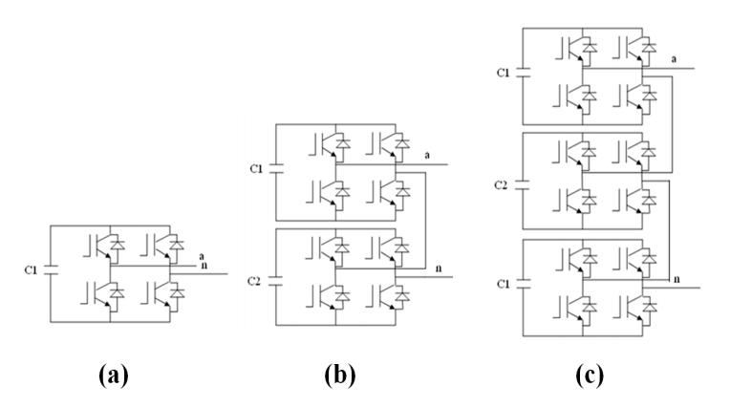
Fig: 3.5 Single phase structures of Cascaded inverter (a) 3-level, (b)5-level,
(c) 7-level
One more alternative for a multilevel inverter is the cascaded multilevel inverter or series H-bridge inverter. The series H-bridge inverter appeared in 1975. Cascaded multilevel inverter was not fully realized until two researchers, Lai and Peng. They patented it and presented its various advantages in 1997. Since then, the CMI has been utilized in a wide range of applications. With its modularity and flexibility, the CMI shows superiority in high-power applications, especially shunt and series connected FACTS controllers. The CMI synthesizes its output nearly sinusoidal voltage waveforms by combining many isolated voltage levels. By adding more H-bridge converters, the amount of Var can simply increased without redesign the power stage, and build-in redundancy against individual H-bridge converter failure can be realized. A series of single-phase full bridges makes up a phase for the inverter. A three-phase CMI topology is essentially composed of three identical phase legs of the series-chain of H-bridge converters, which can possibly generate different output voltage waveforms and offers the potential for AC system phase-balancing. This feature is impossible in other VSC topologies utilizing a common DC link. Since this topology consists of series power conversion cells, the voltage and power level may be easily scaled. The dc link supply for each full bridge converter is provided separately, and this is typically achieved using diode rectifiers fed from isolated secondary windings of a three-phase transformer. Phase-shifted transformers can supply the cells in medium-voltage systems in order to provide high power quality at the utility connection.
3.3.1 Operation of CMLI
The converter topology is based on the series connection of single-phase inverters with separate dc sources. Fig 3.5 shows the power circuit for one phase leg of a three-level, five-level and seven-level cascaded inverter. The resulting phase voltage is synthesized by the addition of the voltages generated by the different cells. In a 3-level cascaded inverter each single-phase full-bridge inverter generates three voltages at the output: +Vdc, 0, -Vdc (zero, positive dc voltage, and negative dc voltage). This is made possible by connecting the capacitors sequentially to the ac side via the power switches. The resulting output ac voltage swings from -Vdc to +Vdc with three levels, -2Vdc to +2Vdc with five-level and -3Vdc to +3Vdc with seven-level inverter. The staircase waveform is nearly sinusoidal, even without filtering.For a three-phase system, the output voltage of the three cascaded converters can be connected in either wye (Y) or delta (Δ) configurations. For example, a wye-configured 7-level converter using a CMC with separated capacitors is illustrated in the Fig 3.6.

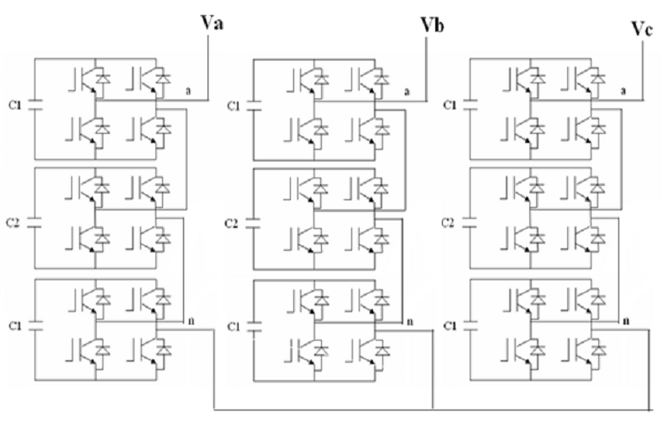
Fig: 3.6 Three-phase 7-level cascaded multilevel inverter (Y-configuration)
3.3.2 Features of CMLI
For real power conversions, (ac to dc and dc to ac), the cascaded-inverter needs separate dc sources. The structure of separate dc sources is well suited for various renewable energy sources such as fuel cell, photovoltaic, and biomass, etc. Connecting separated dc sources between two converters in a back-to-back fashion is not possible because a short circuit will be introduced when two back-to-back converters are not switching synchronously.
3.3.3 Advantages and Disadvantages of CMLI
Advantages:
1. The regulation of the DC buses is simple.
2. Modularity of control can be achieved. Unlike the diode clamped and capacitor clamped inverter where the individual phase legs must be modulated by a central controller, the full-bridge inverters of a cascaded structure can be modulated separately.
3. Requires the least number of components among all multilevel converters to achieve the same number of voltage levels.
Disadvantages:
1. Communication between the full-bridges is required to achieve the synchronization of reference and the carrier waveforms.
2. Needs separate dc sources for real power conversions, and thus its applications are somewhat limited
Conclusion
The aim of this chapter has been to demonstrate the multilevel converter topologies. Each has its own mixture of advantages and disadvantages and for any one particular application, one topology will be more appropriate than the others. Often, topologies are chosen based on what has gone before, even if that topology may not be the best choice for the application. The advantages of the body of research and familiarity within the engineering community may out weight other technical disadvantages.

4. DC VOLTAGE CONTROLLER FOR STATCOM WITH LOAD
4.1 Introduction

Shunt connected controllers at distribution and transmission levels usually fall under two categories-Static Synchronous Generators (SSG) AND Static VAR Compensators (SVC). A Static Synchronous Generator is defined by IEEE as a self-commutated switching power converter supplied from an appropriate electric energy source and operating to produce a set of adjustable multiphase voltages, which may be coupled to an ac power system for purpose of exchanging independently controllable real and reactive power. When the active energy source (usually battery bank, Superconducting Magnetic Energy Storage etc) is dispensed with and replaced by a DC capacitor which can not absorb or deliver real power except for short durations the SVG becomes a Static Synchronous Compensator (STATCOM). STATCOM has no long term energy support in the DC side and cannot exchange real power with ac system; however it can exchange reactive power. Also in principle it can exchange harmonic power too. But when a STATCOM is designed to handle reactive power and harmonic currents together it gets a new name-Shunt Active Power Filter. So a STATCOM handles only fundamental reactive power exchange with ac system STATCOM employed at distribution and transmission levels-though for different purposes.
When a STATCOM is employed at distribution level for at the load end for power factor improvement and voltage regulation alone it is called DSTATCOM. When it is used to do harmonic filtering in addition or exclusively it is called active power filter. In transmission system STATCOM handle only fundamental reactive power and provide voltage support to buses. STATCOM at distribution and transmission levels are designed using PWM Voltage Source Inverter based Static VAR Compensators referred to as SVC here onwards began to be consider a viable alternative to the existing passive shunt compensators and Thyristor Controlled Reactor(TCR) based compensators from mid eighties onwards. The disadvantages of capacitor/Inductor are well known. TCRs could overcome many of the disadvantages; namely slow response to a VAR command and injection of considerable amount of harmonic currents into the power system which had to be canceled by special transformers and filtered by heavy passive filters. The PWM STATCOMs are capable of delivering lagging/leading VARs to a load or to a bus in the power system in a rapidly controlled manner.
4.2. Proposed multilevel circuit topology
4.2.1. Principle of Operation
The proposed asymmetric-twin-converter-based multilevel topology, comprising two VSCs, is shown in Figure 4.1. Low voltage (LV) windings of the transformer are connected differentially between two 2-level VSCs such that the voltage appearing on the LV side is the difference of the output voltages of two VSCs. High-voltage (HV) windings, arranged in a star configuration, are connected to the three-phase grid. Leakage inductances of the transformers act as input filter inductances of the STATCOM. Both VSCs operate with separate dc links to produce two-level individual output. Voltages appearing on the LV windings of the transformer are written in terms of output voltages of VSCs as
Figure 4.1: Asymmetric-twin-converter-topology-based STATCOM.
(4.1)
where e_{a}, e_{a1g1}, e_{a2g2}, and e_{g1g2} are the voltages across the LV winding of phase-a, the pole voltage of VSC-1, the pole voltage of VSC-2, and the voltage difference between negative dc-link terminals of the two VSCs, respectively. Since both VSCs have separate dc links, the sum of the LV winding phase currents should be zero
(4.2)
Furthermore, the sum of instantaneous values of grid voltages is equal to zero
(4.3)
The sum of the LV winding voltages is given by
(4.4)
where r and L are the resistance and leakage inductance as measured from the LV side, respectively, and N_{LV}/N_{HV} is the turns ratio. Substituting (4.2) and (4.3) into (4.4) gives (4.5)
Substituting LV voltages from (4.1) in (4.5) results in
(4.6)
Substituting the value of e_{g1g2} in (4.1) yields
(4.7)
The relation between LV winding voltages and pole voltages is expressed in (4.7). Pole voltages depend on the conduction state of the switches in VSC-1 and VSC-2.
(4.8)
For v_{dc2} = 0.5v_{dc1}, depending on the state of switches, voltage waveforms of e_{ab}, e_{bc}, and e_{ca} has seven different steps. This is same as the number of steps obtained in the line voltage of four-level diode clamped multilevel converter. For v_{dc2} = 0.366v_{dc1}, nine different steps are observed in the line voltage waveforms, which is the same as that in four-level diode clamped converter with the capacitor voltage ratio v_{dc1} : v_{dc2} : v_{dc3} equal to 0.33:0.66:0.33. This makes the proposed scheme equivalent to a four-level converter.
4.2.2. Development of the equivalent circuit of the system
Figure 4.2: Equivalent circuit diagram of the proposed STATCOM.
For the purpose of analysis, an equivalent circuit of the proposed STATCOM is derived and is shown in Figure 4.2. Transformer is represented by equivalent series combination of inductances, resistances, and voltage sources. To model the losses in two VSCs, two resistances r₁ and r₂ are placed in parallel to the two dc links. The governing equations of the proposed system can be derived as
(4.9)
where L is defined as ω_{b}l/z_{base}. l, ω_{b}, and z_{base} are the leakage inductance, base frequency, and base impedance of STATCOM. All the parameters and variables are expressed in per-unit (p.u.) system. Equation (4.9) is transformed into dq0 reference frame, which has been defined in the Appendix. The system variables in the dq0 frame are expressed as follows:
(4.10)
where i_{d} and i_{q} are the d- and q-axis components of LV-side currents. e_{d1} and e_{q1} are the voltage components of VSC-1, and e_{d2} and e_{q2} are the voltage components of VSC-2. Equation (4.10) interrelates the ac parameters of the STATCOM with those of the grid. The dependence between dc and ac parameters of STATCOM is derived using instantaneous power balance equations. The following equation gives the power balance condition between the ac and dc links of VSC-1:
(4.11)
The current flowing through the dc-link capacitor C₁ is related to the dc-link voltage vdc1 as follows:
(4.12)
where C1 is defined as 1/(ω_{b}C₁z_{base}). Substituting idc1 from (4.11)
(4.13)
Similarly, the governing equation for VSC-2 is expressed as
(4.14)
Equations (4.10), (4.13), and (4.14) represent the behaviour of the system. These equations are used in the following section.
4.3. Development of the controller
The proposed asymmetric-twin-converter-based STATCOM has two dc-link voltages v_{dc1} and v_{dc2}. The controller should regulate these two dc-link voltages and govern the total reactive power flowing to/from the STATCOM. The total active power required to overcome losses and regulate dc-link voltages is drawn by STATCOM from the grid. This active power needs to be redistributed among the two dc links. The distribution should ensure that the two dc-link voltages v_{dc1} and v_{dc2} are maintained equal to their corresponding reference values. The suitable controller to achieve these objectives is discussed in this section.
4.3.1. Current Control
The overall system is represented by two coupled differential equations, as depicted in (4.10). To decouple them, two variables x₁ and x₂ are defined such that
(4.15)
(4.16)
By combining (4.10) with (4.15) and (4.16), the decoupled system equations are obtained as follows:
(4.17)

Applying small-signal analysis on the decoupled system of (4.17), the small-signal plant transfer function is derived as
(4.18)

Figure 4.3: Controller for STATCOM.
Control variables x₁ and x₂ govern the system currents i_{d} and i_{q}, respectively, as per the differential equation (4.17). Therefore, current control is achieved by controlling variables x₁ and x₂ using the errors between reference values and actual currents, as given by
(4.19)
(4.20)
Required LV voltages e_{d1} − e_{d2} and e_{q1} − e_{q2} are derived by using these values of x1 and x2 in (4.15) and (4.16). To generate these voltages, modulation signals for the VSCs are derived as follows:
(4.21)

An inner current controller is implemented using (4.15), (4.16) and (4.19)–(4.21), as shown in Fig. 4.3.
The inner current controller generates the modulating waveforms of LV voltages (m_{d1vdc1} − m_{d2vdc2}) and (m_{q1vdc1} − m_{q2vdc2}). However, modulating waveforms for individual VSCs m_{d1}, m_{d2}, m_{q1}, and m_{q2} have to be derived from these LV voltages. This distribution is used to regulate real power exchange between the two VSCs. Furthermore, the current controller requires the reference current signals i_{d_ref} and i_{q_ref} as inputs. The phase-locked loop is synchronized with the grid voltage such that q component of the grid voltage is kept equal to zero. Therefore, the total active and reactive powers absorbed or supplied by the STATCOM are proportional to i_{d_ref} and i_{q_ref} , respectively. The outer cascaded controller generates the reference current signals i_{d_ref} and i_{q_ref} such that the system variables (total reactive power and two dc-link voltages) are maintained at their respective reference values.
4.3.2. Reactive Power Control
STATCOMs are commonly used either for transmission line voltage support or for reactive power compensation of load. For voltage support of the transmission line, the reactive current reference i_{q_ref} is controlled by the deviation of the transmission-line voltage from its nominal value. On the other hand, for load compensation operation, the reactive current reference i_{q_ref} is controlled by the deviation of source power factor from its required value. In both the aforementioned cases, i_{q_ref} will be supplied to the current controller by a higher level controller. The issues pertaining to the higher level controller are kept outside the purview of this paper.
4.3.3. DC Voltage Control
A dc voltage controller should ensure that the two dc-link voltages v_{dc1} and v_{dc2} are regulated at their reference values. This problem is divided into two separate control objectives: first, to maintain the sum of two dc-link voltages (v_{dc1} + v_{dc2}) that is equal to the sum of their reference values (v_{dc1−ref} + v_{dc2−ref} ) and, second, to maintain the difference of the two dc link voltages (v_{dc1} − v_{dc2}) that is equal to the difference of their reference values (v_{dc1−ref} − v_{dc2−ref} ).
1) Sum of DC Voltages: The sum of the dc voltages (v_{dc1} + v_{dc2}) increases with the net real power flow from grid to STATCOM and vice versa. In other words, the error in the sum of dc-link voltages (v_{dc1} + v_{dc2} − v_{dc1−ref} − v_{dc2−ref}) indicates the amount of real power to be absorbed from the grid. Hence, the d-axis reference current i_{d_ref} is controlled by the error existing between reference and actual dc-link voltages of VSCs, as shown in Fig. 4.3.
2) Difference of DC Voltages: System equations (4.13) and (4.14) are coupled equations describing the behavior of the dclink voltages. Considering C1 = C2 = C and subtracting (4.14) from (4.13) give
(4.22)
Where
(4.23)

Substituting modulation signals from (4.21) into (4.23) gives
(4.24)
(4.25)
where the modulation vector −→m = m_{d1} + m_{d2} + j(m_{q1} + m_{q2}) and the current vector −→i = i_{d} + ji_{q}. Considering r1 = r2 = r and applying small-signal analysis on (4.22) give the transfer function
(4.26)
Equation (4.22) gives the relation between the control variable x3 and the difference of dc-link voltages v_{dc1} − v_{dc2}. Therefore, it is inferred that error (v_{dc1_ref} − v_{dc2_ref} ) − (v_{dc1} − v_{dc2}) is to be processed through a proportional–integral controller to obtain the control variable x₃. Hence, the difference in power requirement between VSC-1 and VSC-2 is reflected in x₃. Using it, (−→m • −→i ) is determined from (4.25). To achieve the required power flow between VSCs with low dc-link voltages, the modulation vector −→m is maintained in phase with −→i . Hence
(4.27)
The controller which ensures that the difference of dc voltages v_{dc1} − v_{dc2} is maintained equal to the reference v_{dc1_ref} − v_{dc2_ref} is shown in Fig. 4.3.

4.3.4. Generation of Modulation Signals
The current controller, shown in Fig. 4.3, generates the signals for primary voltages e_{d1} − e_{d2} and e_{q1} − e_{q2}. These are transformed to modulation signals as follows:
(4.28)
Furthermore, the “Difference of DC Voltages” controller generates md1 + md2 and m_{q1} + m_{q2}. By arithmetic operation on the outputs of these two controllers, the individual modulation signals for the two VSCs m_{d1}, m_{q1}, m_{d2}, and m_{q2} are generated by the block “Modulation Signals Generator,” as shown in Fig. 4.3. These signals are then converted to stationary abc frame of reference. The modulation waveforms for the two VSCs are then compared with the carrier waveforms to generate gating signals for VSCs.
4.4. Simulation and Implementation
The Dc voltage controller for asymmetric twin converter based high power STATCOM is modelled and simulated using the MATLAB with its Simulink. The open ended transformer was connected to STATCOM. The PI controller was used to control the STATCOM DC Voltages. The connected circuit is shown in figure 4.4. The available model connected to grid, which includes high distortion under no-load condition.
The control algorithm for the STATCOM is also modeled in MATLAB. A CB-PWM current controller is used over the reference and sensed source currents to generate the gating signals for the IGBTs of the VSC of the STATCOM. The MATLAB-based model of the Asymmetric twin converter topology baed STATCOM with and loads are shown in following sections.
MATLAB model of the DC voltage controller for Asymmetric twin converter topology based STATCOM with PI controller with linear and without non-linear loads is shown in below figures.
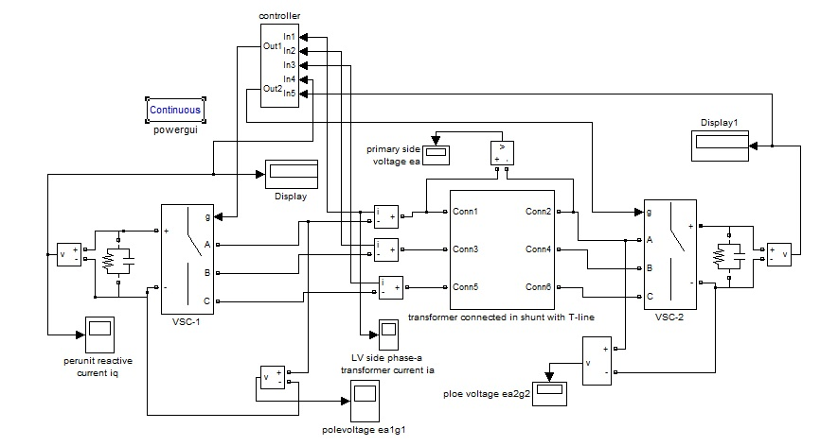
Figure 4.4: Simulated model of asymmetric twin converter based STATCOM with PI controller under no-load
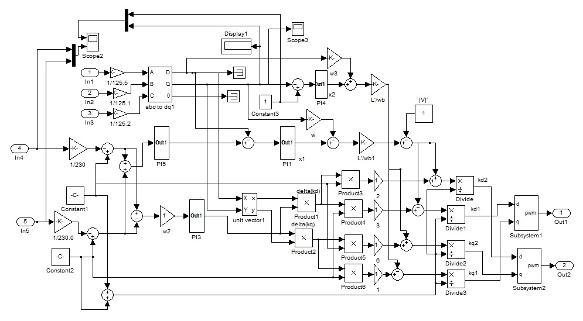
Figure.4.5: Simulation model of controller of STATCOM
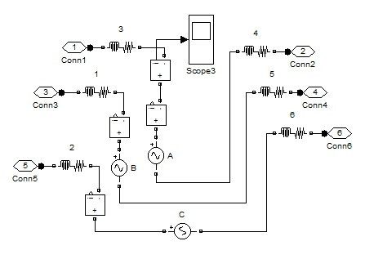
Figure.4.6: Sub system of open-ended transformer

4.4.1. Simulation Results on no-load
In this work the performance of the open-ended transformer and twin converter based-VSC demonstrated for DC voltage control along with harmonic reduction. The developed model is analyzed under varying loads and the results are discussed shortly.
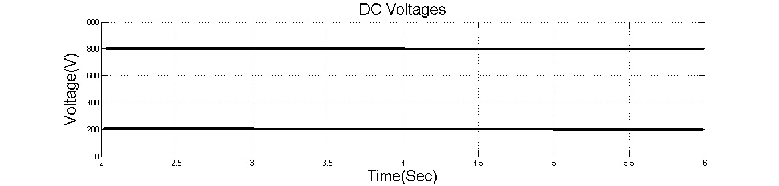
(a)
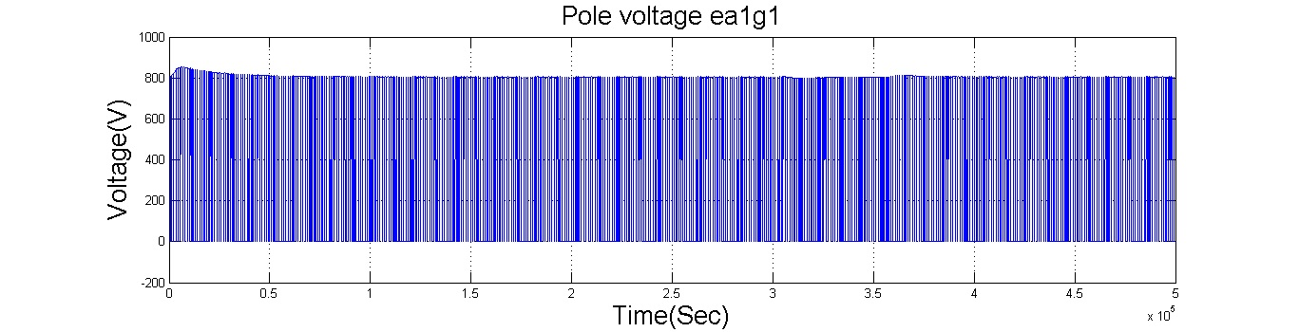
(b)
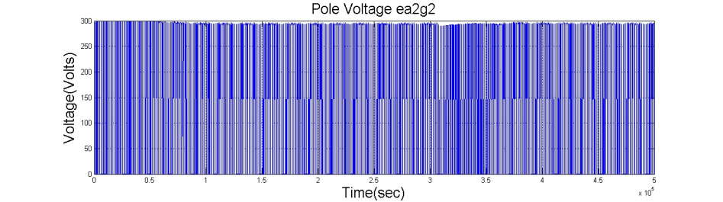
(c)
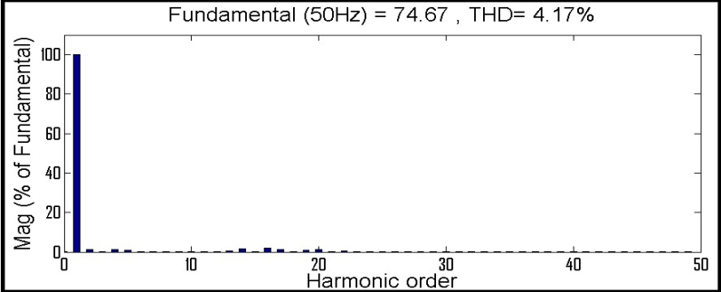
(d)
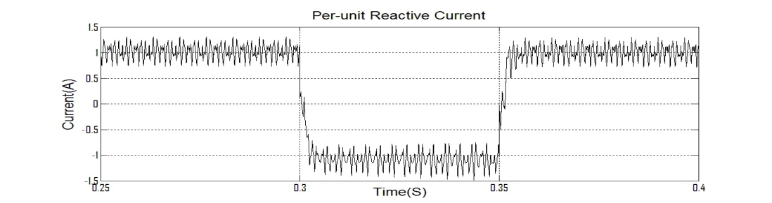
(e)
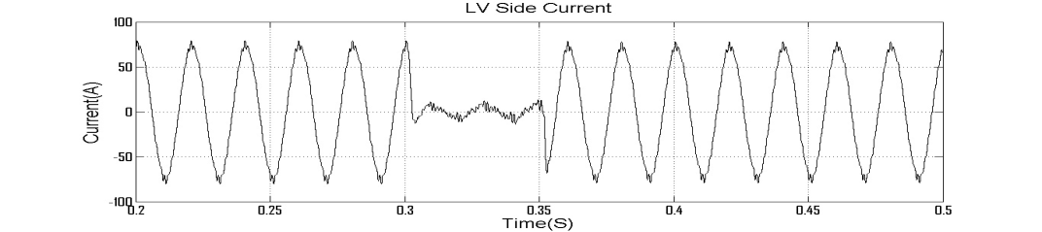
(f)
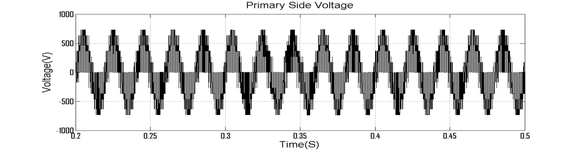
(g)
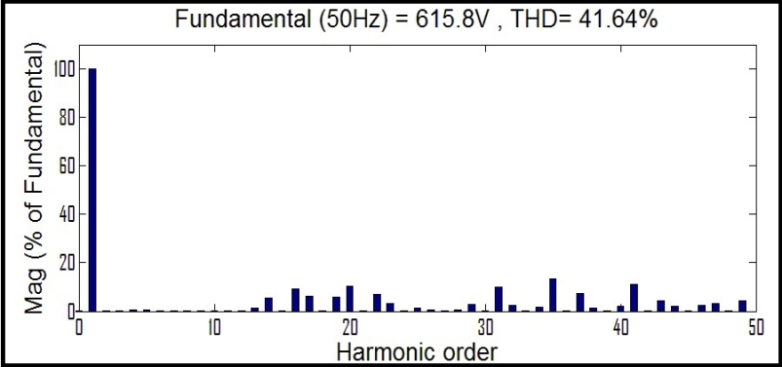
(h)
Figure.4.7.Simulation of STATCOM with PI controller: (a) DC Voltages (b) Pole Voltage ea1g1 (c) Pole Voltage ea2g2 (d) Harmonic Spectrum of Phase-a current (e) Per-Unit reactive current (f) LV Side current (g) Primary Side Voltage (h) Harmonic spectrum of LV-Side voltage ea

4.5. Performance of STATCOM with Linear load:
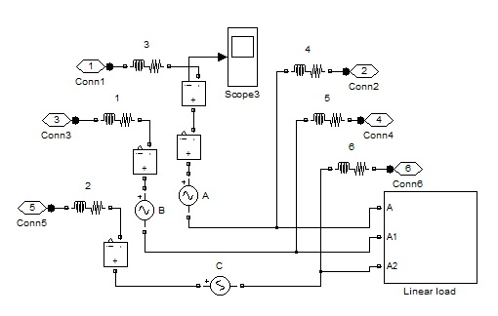
Figure.4.8: Simulation of Linear load connected to open-ended transformer
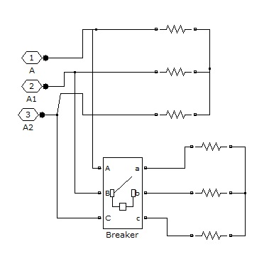
Figure.4.9: Subsystem of Linear load

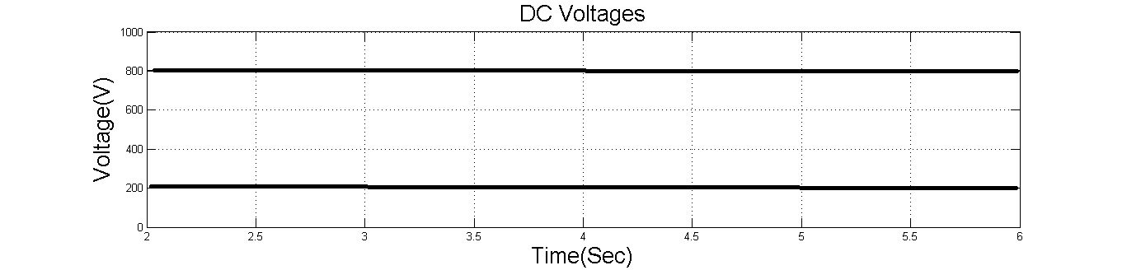
(a)
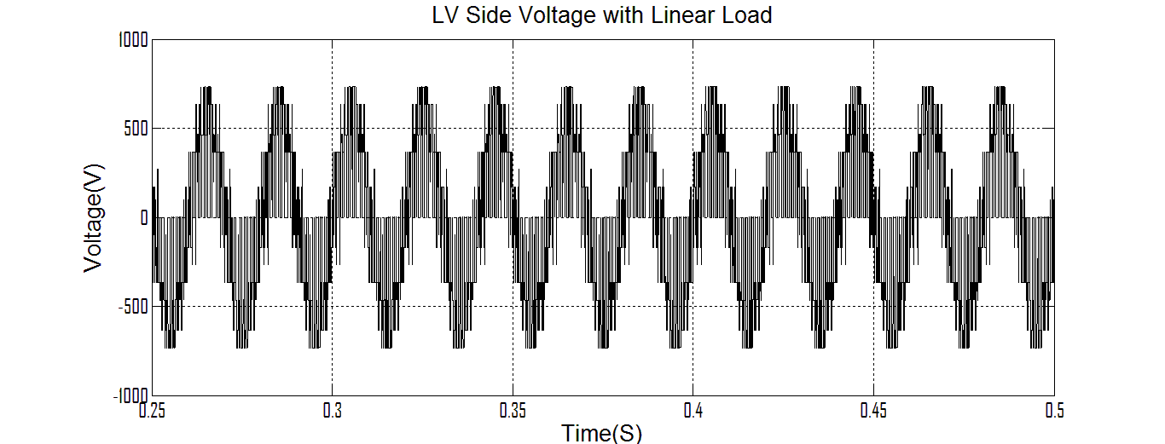
(b)

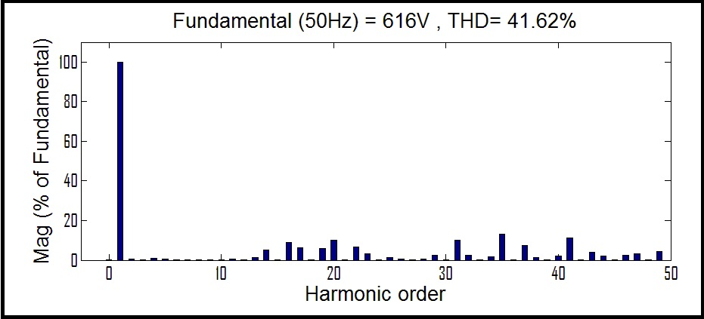
(c)

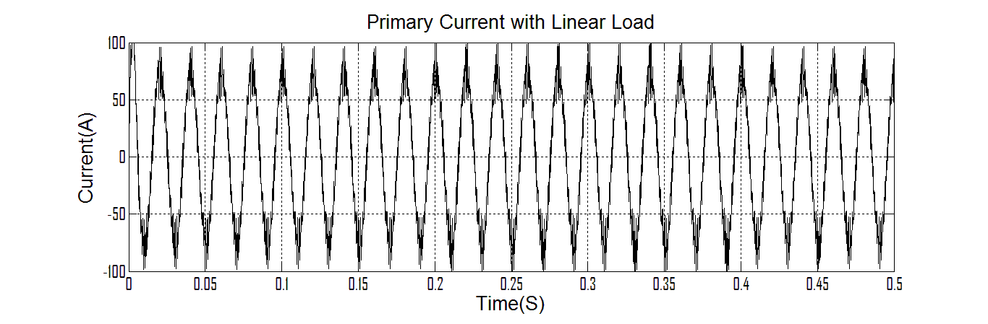
(d)

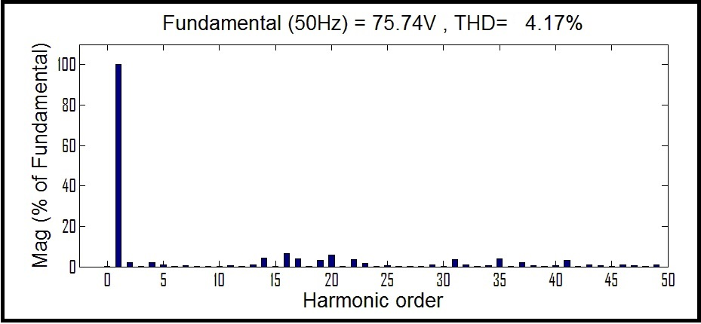
(e)
Figure.4.10. Simulated linear load results: (a) DC Voltages (b) LV Side Voltage with linear load (c) Harmonic spectrum of LV-side voltage ea (d) Primary side current with linear load (e) Harmonic Spectrum of Phase-a current
4.6. Performance of STATCOM with Non-linear load
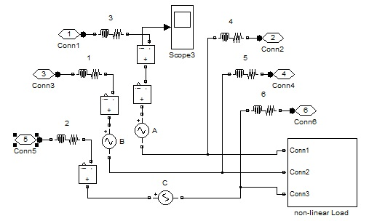
Figure.4.11: Simulation of non-linear load connected to open-ended transformer
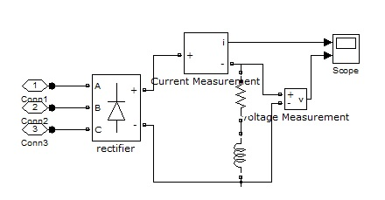
Figure.4.12: Subsystem of non-linear load

(a)
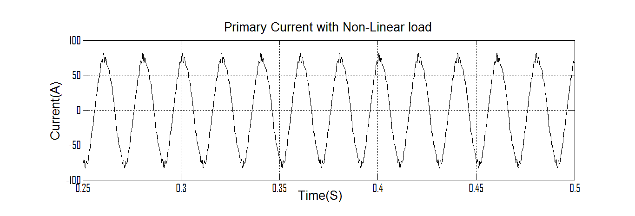
(b)
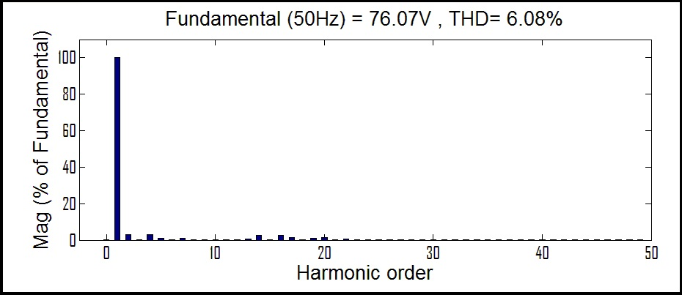
(c)
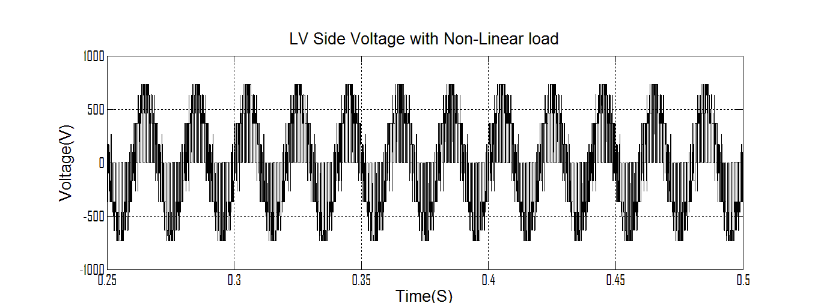
(d)
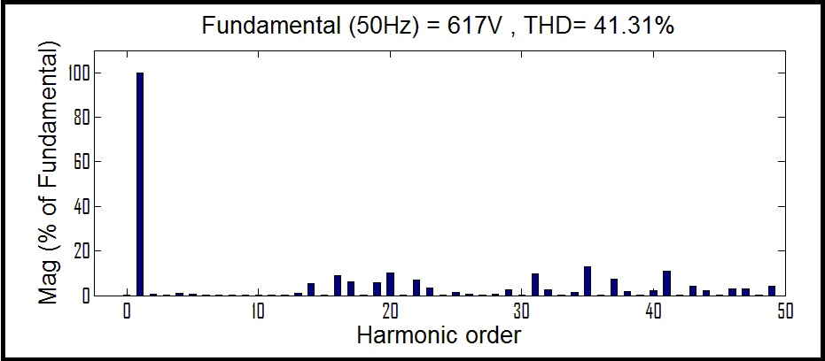
(e)
Figure.4.13. Simulated non-linear load results: (a) DC Voltages (b) Primary side current with non-linear load (c) Harmonic Spectrum of Phase-a current (d) LV Side Voltage with non-linear load (e) Harmonic spectrum of LV-side voltage ea.
4.7 Discussions
The performance of the PI controller for the STATCOM is analyzed in terms of %THD values of LV side current, and primary side voltages under Linear and non-linear conditions. The total harmonic distortion, LV side current, and primary side voltages under fault conditions is observed from Table 3.
Table.4.1. Total Harmonic Distortion(THD) under load
Type of load | Vdc1 | Vdc2 | %THD  i_{a} | %THD  e_{a}
Linear load | 804.4 | 293.8 | 4.17% | 41.62%
Non-linear load | 804.7 | 293.8 | 6.08% | 41.31%

5. DC VOLTAGE CONTROLLER FOR STATCOM UNDER FAULT CONDITIONS
5.1 Simulation and Implementation
The Dc voltage controller for asymmetric twin converter based high power STATCOM is modelled and simulated using the MATLAB with its Simulink. The open ended transformer was connected to STATCOM. The PI controller was used to control the STATCOM DC Voltages. The connected circuit is shown in figure 4.3. The available model connected to grid, which includes high distortion with and without load conditions.
The control algorithm for the STATCOM is also modeled in MATLAB. A CB-PWM current controller is used over the reference and sensed source currents to generate the gating signals for the IGBTs of the VSC of the STATCOM. The MATLAB-based model of the Asymmetric twin converter topology based STATCOM with fuzzy controller shown in figure 5.1. the available model connected to grid, which includes different load and fault conditions.
MATLAB model of the DC voltage controller for Asymmetric twin converter topology based STATCOM with PI controller with linear and without non-linear loads under fault conditions are shown in following sections.
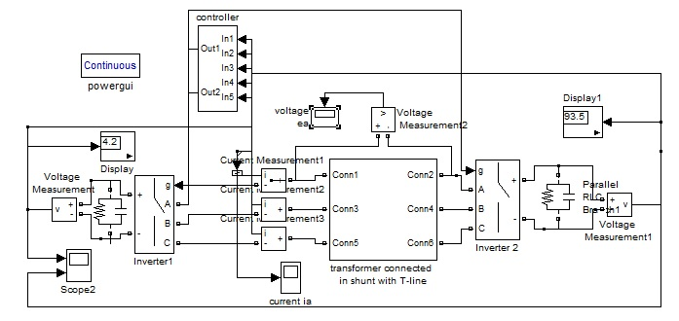
Figure 5.1: Simulated model of asymmetric twin converter based STATCOM.
Figure 5.2: Simulation model of controller for STATCOM
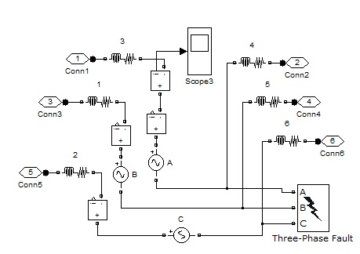
Figure.5.3: subsystem of open-ended transformer with 3-phase fault

5.2 Simulated 3-phase fault with non-linear load results
(a)
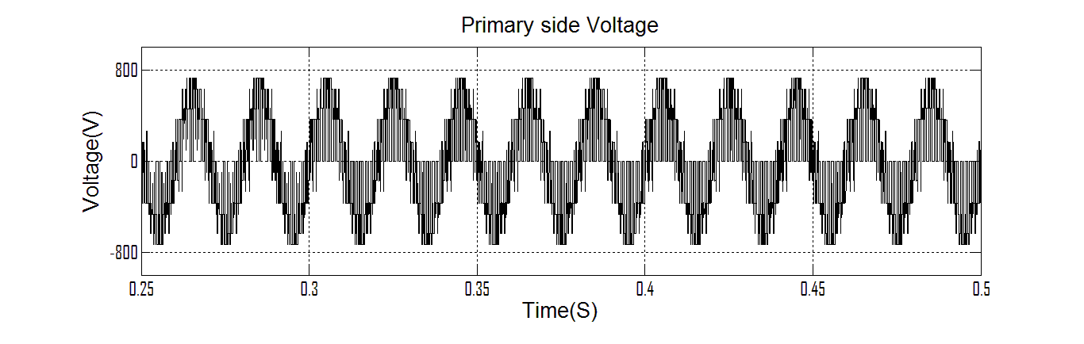
(b)
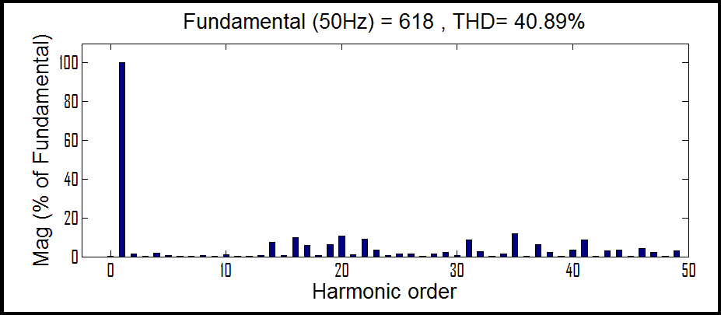
(c)
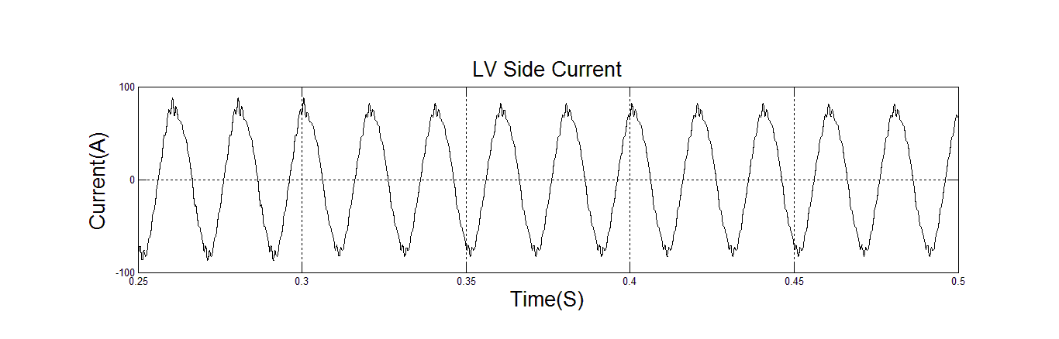
(d)
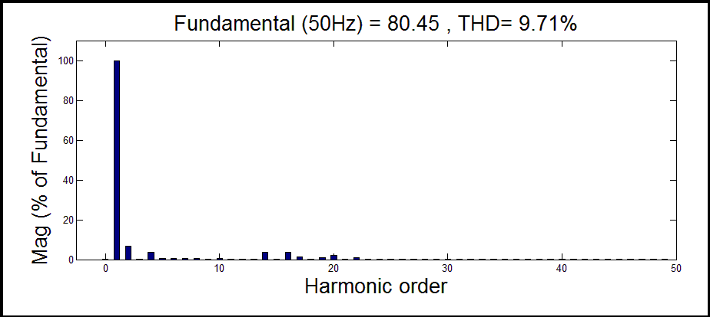
(e)
Figure 5.4.Simulated 3-phase fault with non-linear load results: (a) DC Voltages (b) LV Side Voltage with non-linear load (c) Harmonic spectrum of LV-side voltage ea (d) Primary side current with non-linear load (e) Harmonic Spectrum of Phase-a current.
5.3 Simulated LG fault with non-linear load results
(a)
(b)

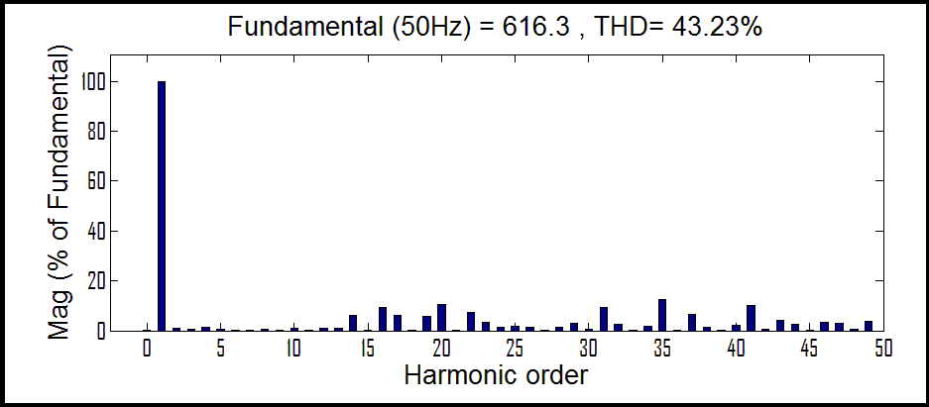
(c)
(d)
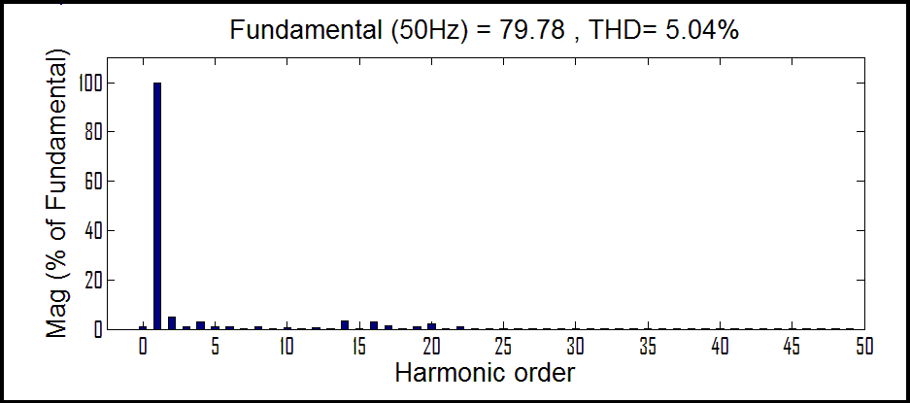
(e)
Figure 5.5.simulation of LG faults with non-linear load: (a) DC Voltages (b) LV Side Voltage with non-linear load (c) Harmonic spectrum of LV-side voltage ea (d) Primary side current with non-linear load (e) Harmonic Spectrum of Phase-a current.

5.4 Simulated LL fault non-linear load results
(a)
(b)
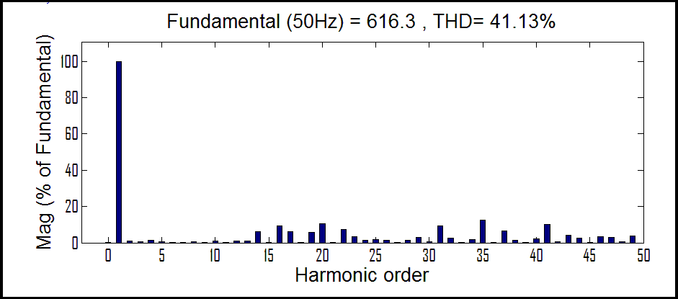
(c)
(d)
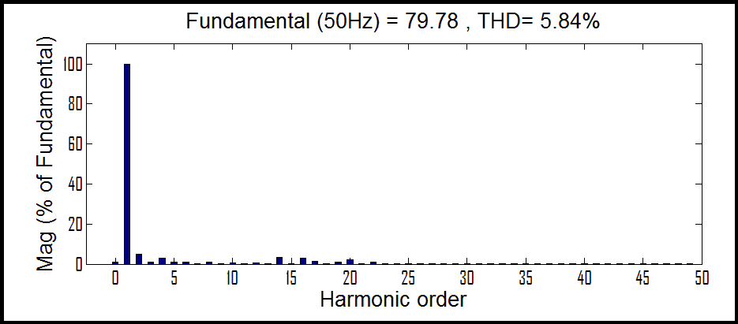
(e)
Figure 5.6.simulation of LL faults with non-linear load: (a) DC Voltages (b) LV Side Voltage with non-linear load (c) Harmonic spectrum of LV-side voltage ea (d) Primary side current with non-linear load (e) Harmonic Spectrum of Phase-a current.
5.5 Simulated 3-phase fault linear load results
(a)
(b)

(c)
(d)
(e)
Figure 5.7.simulated 3-phase fault linear load results: (a) DC Voltages (b) LV Side Voltage with linear load (c) Harmonic spectrum of LV-side voltage ea (d) Primary side current with linear load (e) Harmonic Spectrum of Phase-a current.

5.6 Simulated LG fault linear load results
(a)
(b)
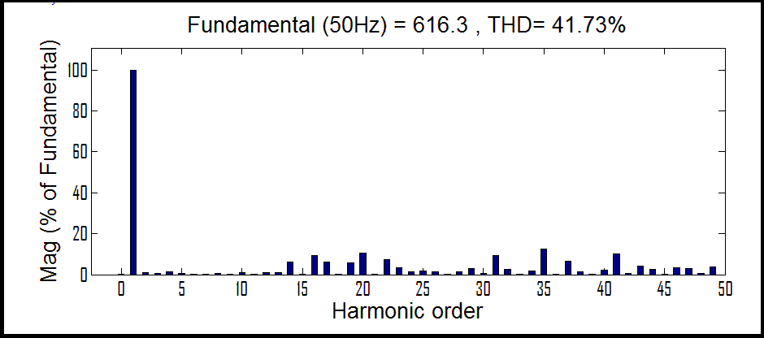
(c)
(d)
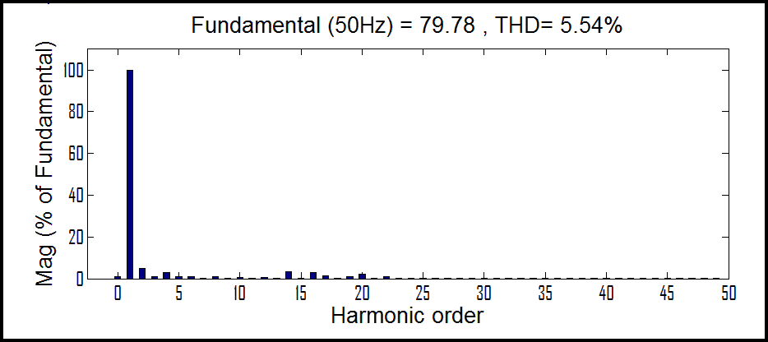
(e)
Figure 5.8.simulation of LG faults with linear load: (a) DC Voltages (b) LV Side Voltage with linear load (c) Harmonic spectrum of LV-side voltage ea (d) Primary side current with linear load (e) Harmonic Spectrum of Phase-a current

5.7 Simulated LL fault linear load results

(a)

(b)
(c)
(d)
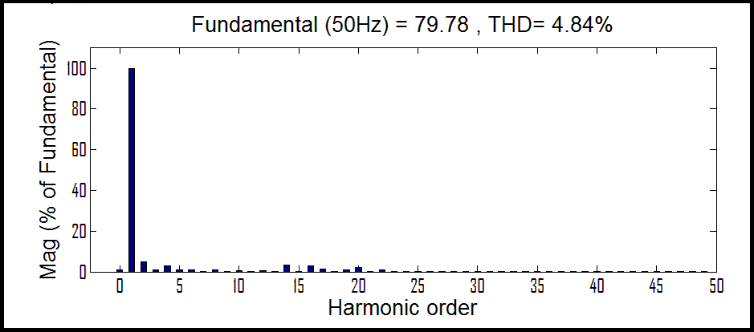
(e)
Figure 5.9.simulation of LL faults with linear load: (a) DC Voltages (b) LV Side Voltage with linear load (c) Harmonic spectrum of LV-side voltage ea (d) Primary side current with linear load (e) Harmonic Spectrum of Phase-a current

5.8 Comparisons

THD Without Controller
(a)
THD With Controller
(b)
Fig 5.10 THD a) without controller b) with controller
5.8 Discussions
The performance of the PI controller for the STATCOM is analyzed in terms of %THD values of LV side current, and primary side voltages under different fault conditions. The total harmonic distortion, LV side current, and primary side voltages under fault conditions is observed from Table 2.

Table.5.1. Total Harmonic Distortion(THD) under non-linear load
Type of fault | V_{dc1} | V_{dc2} | %THD  i_{a} | %THD  e_{a}
3-phase fault | 804.7 | 293.8 | 9.71% | 40.89%
Line-Line fault | 805.1 | 294.2 | 5.84% | 41.13%
Line-Ground fault | 804.9 | 294.2 | 5.04% | 43.13%
Table.5.2. Total Harmonic Distortion (THD) under linear load
Type of fault | V_{dc1} | V_{dc2} | %THD  i_{a} | %THD  e_{a}
3-phase fault | 804.4 | 294.2 | 9.7% | 40.89%
Line-Line fault | 804.9 | 293.2 | 4.84% | 41.73%
Line-Ground fault | 805.1 | 294.2 | 5.54% | 41.3%
The performance of the PI and Fuzzy controller based control techniques for the STATCOM, is analyzed in terms of %THD values. This shows the satisfactory performance of Fuzzy controller for harmonic compensation.
Table.5.3
Comparison of PI and Fuzzy controller Total Harmonic Distortion (THD)
Type of controller | THD of current | THD of voltage
PI controller | 4.17% | 41.64%
Fuzzy controller | 0.74% | 26.53%

CONCLUSION AND FUTURE SCOPE
6.1 Conclusion
- In this work component count was reduced, simpler layout of switches, and reduced capacitance requirement are the attractive features of the scheme over the diode clamped and cascaded multilevel converters.
- In the proposed topology, only two dc voltages have to be controlled. Furthermore, the ratio of the dc-link voltages of the two VSCs is selected such that low distortion in current is achieved.
- The DC voltages, total harmonic distortion (THD) of primary side voltage and LV side current under various load conditions and fault conditions are observed using PI controller.
- The PI controller was replaced by Fuzzy controller and results are analysed. The total harmonic distortion (THD) of primary side voltage and LV side current are less as compared to the PI controller.

6.2 Future Scope
In this work the PI and Fuzzy controller based control techniques for STATCOM proposed and results were analyzed. The proposed technique can be replaced by a Neuro-Fuzzy based control technique to get better THD response.

REFERENCES
- S. Anand, B. G. Fernandes, and K. Chatterjee, “A new 4-level open-ended transformer based STATCOM for high power applications,” in Proc. 36th Annu. IEEE IECON, Nov. 7–10, 2010, pp. 1957–1962.
- C. Schauder and H. Mehta, “Vector analysis and control of advanced static VAR compensators,” Proc. Inst. Elect. Eng. C—Gener., Transm. Distrib., vol. 140, no. 4, pp. 299–306, Jul. 1993.
- E. M. John, A. Oskoui, and A. Petersson, “Using a STATCOM to retire urban generation,” in Proc. IEEE Power Syst. Conf. Expo., Oct. 2004, vol. 2, pp. 693–698.
- D. Soto and T. C. Green, “A comparison of high-power converter topologies for the implementation of FACTS controllers,” IEEE Trans. Ind. Electron., vol. 49, no. 5, pp. 1072–1080, Oct. 2002.
- J. Rodriguez, J.-S. Lai, and F. Z. Peng, “Multilevel inverters: A survey of topologies, controls, and applications,” IEEE Trans. Ind. Electron., vol. 49, no. 4, pp. 724–738, Aug. 2002.
- Y. Cheng, C. Qian, M. L. Crow, S. Pekarek, and S. Atcitty, “A comparison of diode-clamped and cascaded multilevel converters for a STATCOM with energy storage,” IEEE Trans. Ind. Electron., vol. 53, no. 5, pp. 1512– 1521, Oct. 2006.
- H. Abu-Rub, J. Holtz, J. Rodriguez, and G. Baoming, “Medium-voltage multilevel converters—State of the art, challenges, and requirements in industrial applications,” IEEE Trans. Ind. Electron., vol. 57, no. 8, pp. 2581–2596, Aug. 2010.
- S. Kouro, M. Malinowski, K. Gopakumar, J. Pou, L. G. Franquelo, B.Wu, J. Rodriguez, M. A. Pérez, and J. I. Leon, “Recent advances and industrial applications of multilevel converters,” IEEE Trans. Ind. Electron., vol. 57, no. 8, pp. 2553–2580, Aug. 2010.
- F. Z. Peng, J. W. McKeever, and D. J. Adams, “A power line conditioner using cascade multilevel inverters for distribution systems,” IEEE Trans. Ind. Appl., vol. 34, no. 6, pp. 1293–1298, Nov./Dec. 1998.
- K. V. Patil, R. M. Mathur, J. Jiang, and S. H. Hosseini, “Distribution system compensation using a new binary multilevel voltage source inverter,” IEEE Trans. Power Del., vol. 14, no. 2, pp. 459–464, Apr. 1999.
- C. K. Lee, S. Y. Ron Hui, and H. S. Chung, “A 31-level cascade inverter for power applications,” IEEE Trans. Ind. Electron., vol. 49, no. 3, pp. 613–617, Jun. 2002.
- H. Akagi, S. Inoue, and T. Yoshii, “Control and performance of a transformerless cascade PWM STATCOM with star configuration,” IEEE Trans. Ind. Appl., vol. 43, no. 4, pp. 1041–1049, Jul./Aug. 2007.
- M. Malinowski, K. Gopakumar, J. Rodriguez, and M. A. Perez, “A survey on cascaded multilevel inverters,” IEEE Trans. Ind. Electron., vol. 57, no. 7, pp. 2197–2206, Jul. 2010.
- Y. Fukuta and G. Venkataramanan, “DC bus ripple minimization in cascaded H-bridge multilevel converters under staircase modulation,” in Proc. 37th IEEE IAS Annu. Meeting, 2002, vol. 3, pp. 1988–1993.
- S. Vazquez, J. I. Leon, J. M. Carrasco, L. G. Franquelo, E. Galvan, M. Reyes, J. A. Sanchez, and E. Dominguez, “Analysis of the power balance in the cells of a multilevel cascaded H-bridge converter,” IEEE Trans. Ind. Electron., vol. 57, no. 7, pp. 2287–2296, Jul. 2010.
- S. Lu, S.Mariethoz, and K. A. Corzine, “Asymmetrical cascade multilevel converters with noninteger or dynamically changing DC voltage ratios: Concepts andmodulation techniques,” IEEE Trans. Ind. Electron., vol. 57, no. 7, pp. 2411–2418, Jul. 2010.
- S. Vazquez, J. I. Leon, L. G. Franquelo, J. J. Padilla, and J. M. Carrasco, “DC-voltage-ratio control strategy for multilevel cascaded converters fed with a single dc source,” IEEE Trans. Ind. Electron., vol. 56, no. 7, pp. 2513–2521, Jul. 2009.
- J. A. Barrena, L. Marroyo, M. A. R. Vidal, and J. R. T. Apraiz, “Individual voltage balancing strategy for PWM cascaded H-bridge converterbased STATCOM,” IEEE Trans. Ind. Electron., vol. 55, no. 1, pp. 21–29, Jan. 2008.
- P. Cortes, A. Wilson, S. Kouro, J. Rodriguez, and H. Abu-Rub, “Model predictive control of multilevel cascaded H-bridge inverters,” IEEE Trans. Ind. Electron., vol. 57, no. 8, pp. 2691–2699, Aug. 2010.

